OCR A2 Computer Science Project 2022
Candidate 0367
Analysis 2
Introduction 2
Computational methods 2
Problem recognition 2
Stakeholders 3
Existing solutions 4
Pen and paper 4
Online nonograms 5
Nonograms for traditional video game consoles 6
Proposed computational solution 7
Requirements for the solution including hardware and software 9
Limitations 9
Success criteria 10
Design 12
Design choices 12
Nonogram data representation 12
Bottom-up approach 13
Top-down approach 14
Selection GUI 14
Subroutines and smaller problems 15
Structure of solution 18
User interface 19
Key variables, data structures and classes 21
Test data to be used in iterative development process 21
Implementation 22
Tkinter initialisation 22
Initial backend 23
Inputting test data for the iterative development process 23
Generating row hints 24
Generating horizontal minimum squares 28
Generating column hints 29
Generating vertical minimum squares 31
Backend validation 31
Frontend 35
Toggling between button states 36
Defining immutable cells 37
Debugging the horizontal and vertical buttons 39
Filling in horizontal and vertical hints 41
Debugging the correct horizontal and vertical hints 44
Debugging empty row/columns 45
Final section code 48
Nonogram marking 49
Making user interface more accessible 51
Verify solution 54
Checking lists function 58
Puzzle solving test 60
Main menu/launcher 63
Nonogram creation 65
Final coded solution 66
Evaluation 75
Testing to inform evaluation 75
Nonogram playing mode 75
Nonogram creation mode 77
Evidence of solution 78
Test criteria 78
Maintenance issues and limitations 83
Plenary 83

Analysis

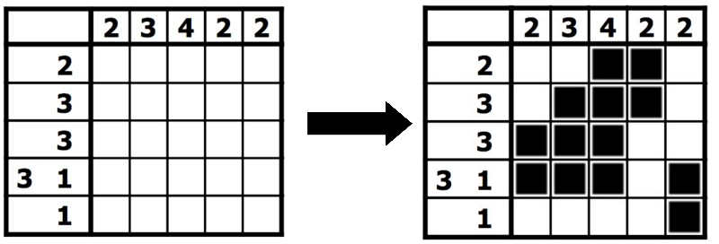
Introduction
Nonograms, also known as hanjie or picross, are a type of visual logic puzzles where cells in a grid are either filled-in or left blank, according to numbers at the side of the grid, which represent the number of consecutive filled-in squares in a given row or column. For example, a clue of “3 1” in a given row means there are sets of three consecutive squares, followed by a gap of at least one square, and then a filled-in square in that order. It is a form of discrete tomography, representing binary images from information and data. While popularised in Japan, where the game was created in Tokyo in 1987, the game has fallen into modern obscurity in western audiences.
The recreational, educational and cognitive merit of the puzzle seems under-recognized, which pertains to its necessity for a computational solution. By applying computational methods to the nonogram problem, there is a strong foundational basis for mathemtical teaching and education.

Computational methods

Problem recognition
Logic puzzles inherently derive from mathematics, specifically deductive logic. Nonograms are an example of an NP-complete problem, the correctness of the solution can be verified computationally quickly (in polynomial time), however a solution cannot be found without using a brute force algorithm. This demands a computational algorithm for validating puzzle solutions as a human takes much longer to verify by hand, and is susceptible to mistakes, especially with larger grid sizes.
The problem can be decomposed to a series of different elements, each mathematically pertinent, between the actual representation of the nonogram puzzle and the horizontal and vertical hints, to the iterative process that would be used for drawing the nonogram puzzle to the user interface.
Having access to nonograms computationally/digitally is more convenient than physical paper, as it is much harder, almost impossible, to retry a puzzle if completed using pen and paper; you are forced to print out or redraw an entirely new puzzle. This is not the case with a digital puzzle, the program allows you to easily correct, rectify and undo mistakes. Not only this, but generation seeds can be easily generated to share nonograms with friends, as each nonogram is easily representable by a hexadecimal value for instance.
A nonogram game of this nature is useful for people of any age, old or young, wanting to enhance their cognitive skills or have fun taking their time on a puzzle. It could also be used to introduce young people to the idea of logic games in a primary or secondary school environment. Developed further, nonograms can be used in game theory and as a model for mathematical representation and analysis.

Stakeholders
Compared to other online games such as platformers and action games, strategy and puzzle games are more accessible to the older generation and provide a very large target demographic. The AARP concluded that most people aged 50 and older who play video games do so on their phones or other mobile devices (73 percent, up from 57 percent in 2016) and the most popular genre of games within this age group were puzzle and logic games (49%). There is a very clear need for logic puzzles, especially from older fans of nonograms who are reluctant to switch to a digital medium of playing. Studies at the Hebrew University of Jerusalem correlate playing of simple games such as sudoku and nonograms with increased episodic memory and grammatical reasoning among adults aged 65 and older, so factoring in the educational and cognitive merits of the game, my stakeholders would include users over the age of 50 who are fans of simple logic games.

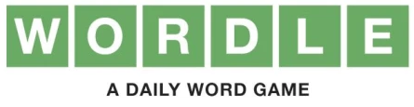
While the popularity of puzzle games has seemingly declined, the recent surge in popularity of the viral game Wordle, a word-based puzzle game, in late December 2021. This proves that there does exist a space in the modern market for puzzle games in an easy and accessible format. One of the key elements attributed to Wordle’s success was the emphasis on social networking: users could easily press a button to copy their results as emoji and share them on social media sites such as Twitter and Facebook, bringing a connective and interactive element to a seemingly single player game. The virality of Wordle has demonstrated that logic puzzles are still relevant with the younger generation. This led me to think about the recreational and educational benefit from having a working computational solution to nonogram puzzles. I believe that having a digital native program for accessing nonograms will be very useful for a large demographic of people.

My stakeholders for this project would include any individual of any age looking for a relaxing game to decrease stress, have fun or improve cognitive function or mathematics skills. One of my friends, Adam, a student in Year 13, frequently completes nonogram puzzles in his spare time. I have decided to target him as the main end user for this project. I asked him if he had interest in a computational solution to playing and solving nonograms and he said yes. I questioned him about what kind of features he would expect to see in a program of this nature and this is what he had to say:
“I would like to have a variety of nonograms with a range of sizes, e.g: easy 5x5, medium 10x10, hard 15x15, etc. Puzzles should have a timer to see how long it takes to complete. The ability to share nonograms and compare times would be useful for me practising against my friends.

Existing solutions

Pen and paper
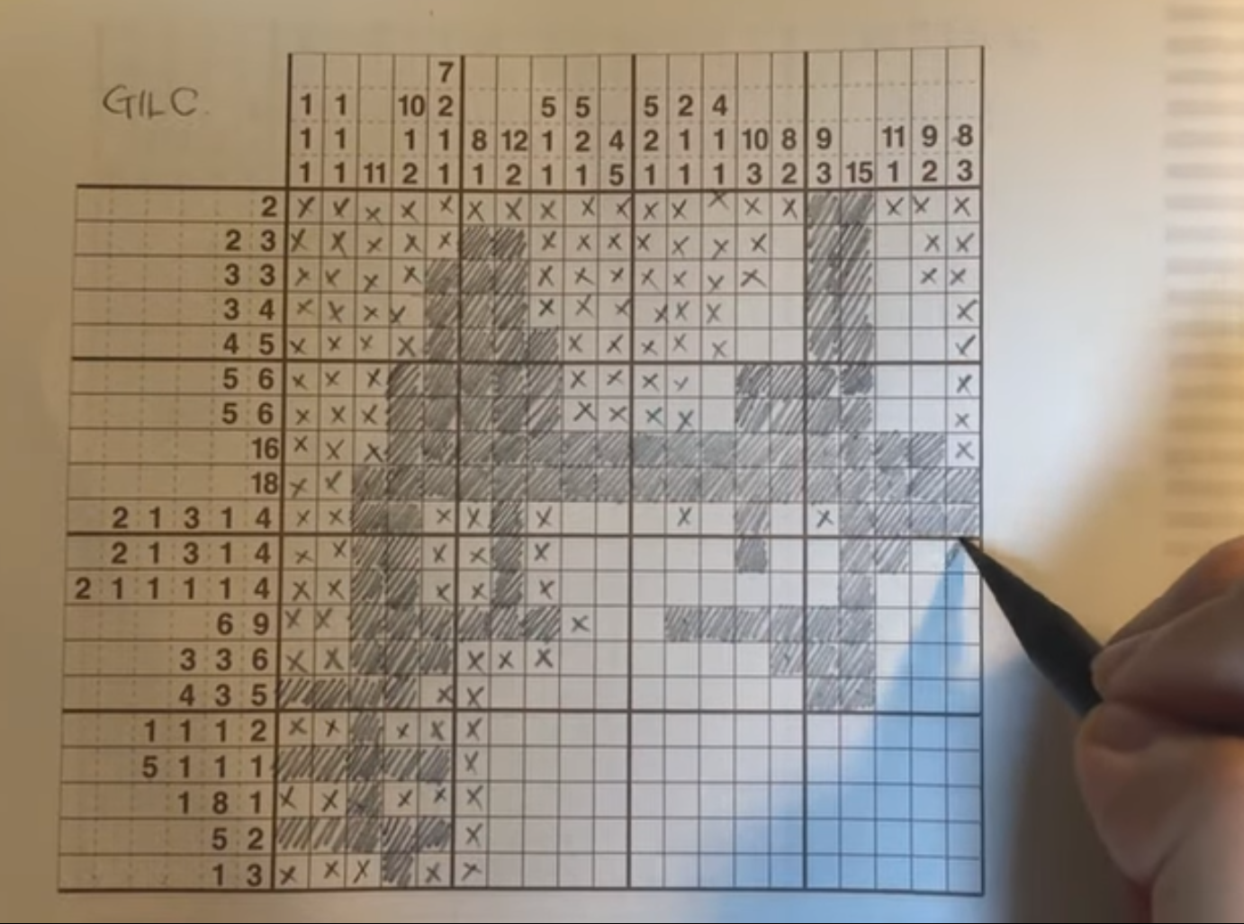
The most traditional medium for nonograms and many other strategy games is pen and paper, which is the original medium the game was distributed in (e.g: newsletters, magazines, etc).
The advantage of this solution is that it doesn’t require digital or computational technologies; anyone can use pen and paper. However, this solution is very inconvenient for multiple reasons: there are few magazines distributed with monogram puzzles, and these come at a cost. It is very hard to correct mistakes on physical paper, and the supply of puzzles is finite and limited, there is only one copy of each puzzle, it is hard to complete the same puzzle with friends.

Advantages | Disadvantages
- Does not require a computer/device  - Older users are already acquainted with pen and paper puzzles | - Requires printing out as it is a physical medium  - Cannot complete the same puzzle multiple times without reprinting  - Hard to correct errors when using a pen or without an eraser  - Less portable  - Harder to share with friends  - Can’t verify solution without answer key  - Much, much longer to manually draw out  etc…

The computational approach to solving this problem should negate almost all of the negatives of a traditional pen and paper solution. It will be accessed natively on a personal computer, and therefore the code can be run as many times as desired. There will be an easy way to correct user-made errors in the game, you can simply left click to toggle between box states, no need to use a pencil and eraser. In addition, you’ll be able to share your puzzles with people easily through just the drag and drop of a file.

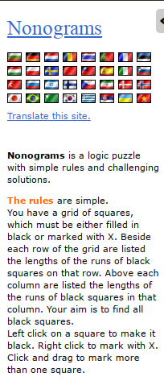
Online nonograms
There are websites online that offer nonogram puzzles at no cost, usually these websites offer a variety of puzzles with nonograms being one of the many to choose from.
A lot of these websites are plagued from bad user experience and overcomplexity, are not optimised for mobile devices or screens with a high PPI (pixels per inch) and therefore unintuitive, and require an active internet connection to access. Many of these issues could be avoided by creating an native GUI application, and could add even more potential functionality such as nonogram creators, allowing users to create their own puzzles and share them with each other, etc. In addition, it would allow offline play, which may be useful to students and elders who can’t guarantee a secure internet connection, even more important due to the effects of the digital divide in the 21st century. The source code could also function as an educational tool for people interested in game theory and mathematics.

Advantages | Disadvantages
- Convenience, no need to download native application  - Sites usually have an abundance of puzzles | - No offline play  - Overcomplicated interface, usually filled with tons of unnecessary and redundant information on screen  - Harder to share nonograms with other users  - Cannot share nonograms with other users while offline

Online nonograms have lots of merits that we could implement in the nonogram project. The ability to verify a nonogram puzzle instantly, comparing the user solution with the original nonogram mark scheme through the press of a button is one of the most convenient features. This completely eradicates all human error from the nonogram-verification process and the verification process happens instantly. I will devise a similar approach based on this when it comes to verifying the solution of the nonogram puzzle in my program.

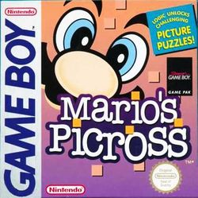
Nonograms for traditional video game consoles
Nintendo have published various nonogram video games under the name ‘Picross’. Their first nonogram game, Mario’s Picross, was released in Japan on March 14 1995, however it failed to become a hit in the U.S. market, even despite a heavy advertising campaign in the western region by Nintendo.
The game has various puzzles of various different difficulties, with each puzzle containing a larger set of puzzles.
Advantages | Disadvantages
- Full working nonogram game  - Lots of levels  - Ability for the user to mark nonograms with a cross to adopt a divide and conquer approach | - Cannot be accessed without the respective console, which are decades old.  - Implementation costs money to buy, for both the console and game.  - Less applicable to an educational or mathematical setting.  - Limited to only the nonograms included on the game
These games created by Nintendo only contain a certain amount of nonogram puzzles and they do not have functionality for the user to create their own. I will address this in my solution; the aim is for my nonogram solution to have a fully functioning ‘create mode’, where users can specify a custom nonogram size and make their own puzzle. After pressing the save button, it will then save it to disk and allow them and other users to play the nonograms they have created.
My nonogram solution will also be free and open source, unlike the nonogram/Picross games created by Nintendo which are proprietary software running on proprietary hardware.
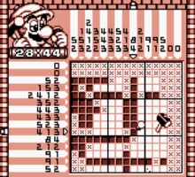
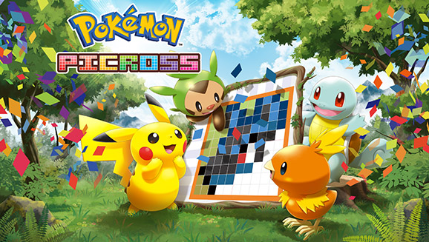

Proposed computational solution
The proposed computational solution would be an application with a graphical user interface written in Python using the Tkinter toolkit. The following features make up the composition of the solution:
- Ability to play nonogram puzzles (core functionality)
  - This is the basic and core functionality of the program as requested by the stakeholder. Ideally, the user would be able to choose between nonogram grid sizes of 5x5, 10x10 and 15x15, potentially with the option to type a numerical value with it to be applied dynamically.
  - This would utilise the graphical user interface written in Tkinter and would feature multiple components:
    - Basic grid: the core of the nonogram puzzle as shown in Figure 1. Users will have the ability to see their progress in the puzzle, and the UI will be interactive via mouse input. Each square within the grid will be clickable, a left click will toggle the square between a filled-in and empty state, while a right click will toggle the square between a cross and an empty state. (A cross is a user note to indicate ‘this square is to be left blank’ and acts as a comment merely to aid the user when completing the puzzle; very similar to placing down a flag in minesweeper)
    - Verify button: Once the user is satisfied with the state of the puzzle, there is a ‘verify button’ that allows users to check their answer. Here, an iterative subroutine can be used to check each row of the user's answer against the preset. As nonograms are an NP-complete problem, the solution can be verified very quickly in polynomial time, so there is no need to store a separate ‘answer key’: the answer can be derived from the puzzle itself.
- Ability to solve nonograms
  - The implementation of this solution is vastly different depending on the implementation of the nonogram data structure. Either the nonogram hints will be stored in data (e.g: 1 3, 2 7, what is shown to the user) will be stored or the completed puzzle will be stored, and the other can be easily generated. If the nonogram hints are stored in data, a brute force algorithm will be necessary to find the correct solution to give to the user. If the nonogram itself is stored in data, the solution can be easily derived from the data (NP-completeness) and there isn’t a need for the brute-force algorithm.
- Ability to share nonograms (core functionality)
  - In addition to a predefined list of puzzles, the ability to share nonograms with other users is a big part of the program and one of the reasons it is so appealing to the stakeholder. By being able to share nonograms, users will have the opportunity to compare puzzles and time taken to beat with friends and there is potential for a leaderboard system for each puzzle.
  - This was the main feature that attributed to the virality and exponential growth of Wordle, one of the existing similar solutions.
- Ability to create nonograms (extended functionality)
  - There is potential to include a built-in editor within the program so that users can create their own puzzles and complete them, or share them with other users.
  - This could be useful for teachers and educators who would like to make preset puzzles in an educational context, or for friends who simply want to make interesting and unique puzzles and share them with each other.
  - This would not require too much adaptation from the core functionality of the program. Instead of validating the puzzle from a preset, the puzzle is instead saved and stored in memory to be shared, played and distributed.
- Main menu (core functionality)
  - This links to all of the previous components and is the default screen when you open the application for the first time. This will have multiple buttons linking to different parts of the app.

Requirements for the solution including hardware and software
The initial solution would be a Python GUI application using Tkinter for the front-end. It would be run as an interpreted Python file on the client machine. It can be run on any computer that supports Python and the Tkinter library, therefore the software can run on Windows, macOS and Linux operating systems without any other additional dependencies other than that in the Python standard libraries. As the product will just be an interpreted script, there should be no special hardware requirements, as long as the hardware is capable of running one of these operating systems.
  - Supported platforms: Windows, macOS and Linux
  - Required software: Python 3 and Tkinter
  - No special or custom hardware requirements

Limitations
The program will have the following limitations:
- No web/mobile interface
  - By default, the GUI will be written in Tkinter and thus can only be run on a desktop operating system. As an extension task, a web front-end or separate mobile front-end could be implemented to get the application running on other operating systems and platforms.
- Access to a computer
  - A computer will be required to use and access the core functionality of the program. This is because a computer is required for computation and to draw the user interface and accept user input.
- No network access
  - It will be an offline script to be run locally. It will not interface with the Internet or local area network. The program could be further developed to interact with an online database of nonograms, allowing for an extensive set of puzzles.

Success criteria
My solution will fulfil the stakeholder if the following criteria are met:
- Working navigation UI and main menu with basic mouse and keyboard support 🖱️ ⌨️ ✅
  - This will be required by the stakeholder to navigate and use the program.
  - This is the bare minimum expectation of the program, the user should be able to interact with all of the elements and access all of the core functionality as specified below.
  - The user interface will be drawn using the Tkinter toolkit, each of the nonogram cells will be represented by buttons on the screen.
- Nonogram interface functional with ability to ‘fill in’ (left click) and ‘flag/mark’ (right click) ✅
  - This functionality of the program should only require two mouse buttons (left and right click), so that it is as easy as possible.
  - The left click and right click functions are both very important parts of the nonogram solution.
    - Left click to fill-in is how the user interacts with the nonogram solution when they are solving it; their solution will be compared against the original nonogram to ensure they have solved the puzzle correctly. Thus, it is important this is a functioning part of the program.
    - Right click to mark is a cosmetic feature that allows the user to embark a ‘divide and conquer’ approach for completing the puzzle. They will be able to mark cells they know are safe similar to the mines in the game Minesweeper, improving the quality of life and user experience.
- Ability to share nonograms directly to people 📦 ✅
  - Having this is an important feature for people wanting to share and distribute puzzles between friends or even students in a class environment.
  - This could either be done by storing the nonograms as files on the local disks where they can be shared between computers, or even a potential networked solution with an online database of nonogram puzzles that users can upload using the built-in nonogram creation tool.
- Nonogram verifying functionality 📑 ✅
  - Being able to verify the user’s solution to the nonogram puzzle is a very important part of the program.
  - After the user thinks they have solved the puzzle, they will press the ‘verify button’ and a copy of their completed nonogram will be stored as an array. This array would then be verified against the original nonogram array from when the puzzle is imported, and if they match, the user is displayed a success message with the elapsed time taken to complete. If the arrays do not match, the user is told they haven’t yet completed the nonogram puzzle.
- Ability to create nonogram puzzles ⚒️ ✅
  - The ability to create nonograms would be a very useful feature to have. The user would be prompted for a horizontal and vertical grid size, and then buttons of those specifications would appear on a grid before them.
  - They would then have the option to fill-in the cells (left click), while right click (marking) functionality would be disabled. Instead of a verify button there would be a ‘save’ button, which would save the state (filled-in or blank) of each cell and represent it as an array. This array would then be saved line by line into a blank text document, with the file name specified by the user.
  - This is important for the end user, especially for those using it as an educational tool, because the functionality to create your own nonograms allows for potential mathematical and educational benefits. It would also be fun for recreational use, allowing users to challenge their friends by giving them tough nonogram puzzles.
Extension/challenge:
- Ability to play puzzles of various sizes with UI scaled appropriately 🧩 ✅
  - This could be done in two ways:
    - Fixed-size nonograms: There are certain nonogram presets such as 5x5, 10x10 or 15x15, etc. Nonograms must be made in this format otherwise the nonogram will fail to load.
    - Dynamically-sized nonograms: The nonogram grid will be initialised dynamically for a custom size. The horizontal and vertical sizes could even be different to one another, allowing for a 20x5 nonogram or a 12x7 nonogram for example.
- Ability to search and share nonograms via an online database 🌐 ✅
  - In the far future, the nonogram program could be adapted to connect to an online database using an Internet connection to share, download and upload nonogram puzzles and distribute them with one another. This would allow for an abundance of nonogram puzzles as the community would be constantly creating them and sharing them.

Design

Design choices
I will be using the Agile development methodology for the duration of this project as it allows a solid iterative technique for constant adaptation of the game features and to get new stakeholder input.

Nonogram data representation
Each nonogram can be easily represented as a binary or hexadecimal value. For example, the first row as shown in Figure 1. can be represented by the following binary string: 00110. The entire nonogram can be represented by a hexadecimal or denary value, a feature of discrete tomography. Originally, I planned to represent each nonogram as a single binary integer. However, this seemed like it would cause problems with determining the size of the puzzle, as in some cases, there would be no representative difference between certain grid sizes. For example, a puzzle consisting of only a single filled-in square at the bottom right would be stored as the binary/hex value “1”, and there would be no way of determining the size of the nonogram.

There are two main approaches that can be taken when representing a nonogram:
- Bottom-up approach: The solution to the puzzle is stored in data (e.g: 00110100…)
- This is much easier to program as there is no need to program a brute force nonogram solver.
- The dimensions of the puzzle are already included in the data.
- This makes the storage of the puzzle in data less efficient. For each set of hints there is only one solution, so storing the hints by itself is more space efficient.
  - However, considering how small the puzzles would be in data (a few B or KB), this is a negligible factor.
- Top-down approach: The nonogram ‘hints’ are the only thing stored in data, and not the solution to the puzzle itself. (e.g: [[2,3],[3,3,1],[1,1],[5]])
- This makes it easier to set up the user interface, the hints are what a new user will start with to begin working the puzzle. We can calculate the solution to the puzzle at any time, including after the user has pressed the ‘verify’ button.
- This is more size efficient, only the necessary data to the puzzle is stored and there are no redundancies.
- There is a need to program a brute force solver. When the user verifies their solution, there needs to be an answer key to check against.
- If just the hints are stored, there is no way to determine the dimension of the puzzle (size of the grid). An extra key needs to be used to store this information.

Bottom-up approach
Below is a completed 9x9 nonogram puzzle of a heart. It would be easy to store this in a simple text file which can be imported into Python. For example:
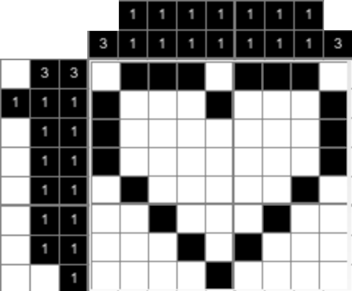
0 | 1 | 1 | 1 | 0 | 1 | 1 | 1 | 0
1 | 0 | 0 | 0 | 1 | 0 | 0 | 0 | 1
1 | 0 | 0 | 0 | 0 | 0 | 0 | 0 | 1
1 | 0 | 0 | 0 | 0 | 0 | 0 | 0 | 1
0 | 1 | 0 | 0 | 0 | 0 | 0 | 1 | 0
0 | 0 | 1 | 0 | 0 | 0 | 1 | 0 | 0
0 | 0 | 0 | 1 | 0 | 1 | 0 | 0 | 0
0 | 0 | 0 | 0 | 1 | 0 | 0 | 0 | 0
Text file containing 1s and 0s (left); Completed nonogram puzzle (right)
For the puzzle to be imported using computational methods, the three pieces of information (vertical size, horizontal size and puzzle contents) need to be readily available. However, it is actually very easy to determine the size of the nonogram from the text file. We can simply ‘count’ the numbers of rows and columns using an iterative routine in program code. A ‘1’ indicates the presence of a filled-in square, while a ‘0’ represents a blank square, which can be represented easily on the program UI grid.

In Python, this could be stored in a two-dimensional array. For example, to initialise the heart nonogram, code could be used as such:
heartNonogram = [[0,1,1,1,0,1,1,1,0],[1,0,0,0,1,0,0,0,1],[1,0,0,0,0,0,0,1],[1,0,0,0,0,0,0,1], ... ]
However, for the purposes of this program, the nonogram will initially be represented by a blank array and the completed rows will be appended through a reading algorithm from local text files. This allows the program to be easily modified for different puzzles by just selecting a different text file.

The menu and user interface will be displayed in Tkinter. There will be a shared user interface for making/designing nonograms and completing nonograms; this will have the benefit of being modular as there will likely be very little changes that will need to be made between the two interfaces. There will also be an interface for selecting and importing the puzzles, if a database of nonograms is implemented there could be a selection menu where the user can choose from a list.

Top-down approach
The nonogram will be stored as two values (“keys”), and the hints for each column and row. One of these keys dictates the horizontal size of the puzzle, the other dictates the vertical size of the puzzle, and the final would dictate the hints to the puzzle itself: essentially the first two values functioning as the “key”. Having two values as a key allows different vertical and horizontal sizes, for example a 10x20 nonogram or a 5x15. As we are not storing the solution to the puzzle itself here, these horizontal and vertical keys are necessary.

Selection GUI
To select the nonogram puzzles, we could use:
- Hardcoded: the filename is hardcoded in the code of the project. This is not a viable expectation for the end user of the program and we will only use this for our own internal purposes during the development of the program. e.g:
filename = "puzzles/heart.txt" # Relative .txt file to be loaded
# Only for development purposes, end user can change this using GUI
- Text entry field: the user types in the relative local file name of the puzzle (e.g: airplane.txt). This input will scan the current directory for the file name given, and will be read in using an algorithm.
- Selection list: upon initialisation of the GUI, the relative data directory scans for valid nonogram files and the user can select them. This could even show other information such as difficulty of the puzzle, horizontal/vertical size, etc.
This could even be extended in the future to send a request to a database and retrieve a list of nonograms online for easily accessing nonograms from other users.
- Randomly generated puzzle: the puzzle could also be randomly generated by the press of a button. A separate algorithm would be required to actually do this, something with a very complicated mathematical method.

Subroutines and smaller problems
We will break down the nonogram project into two main parts. The frontend of the program and the backend of the program.
- Backend
  - This includes parsing the nonogram into an array data structure and generating horizontal and vertical hints based on said array.
  - The generation of the horizontal and vertical hints will execute as an algorithm after the nonogram array is initialised.
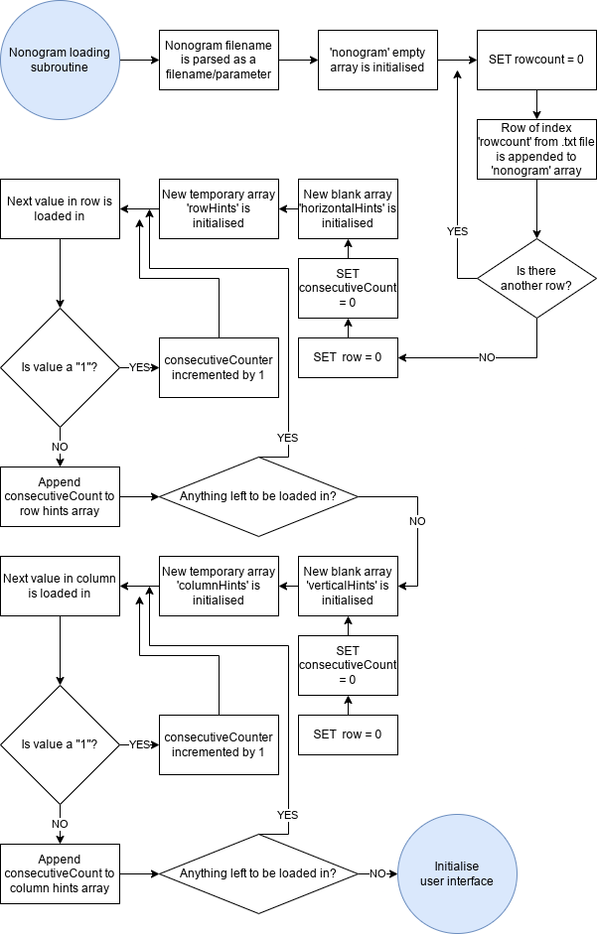
- Frontend
  - Main menu to project
    - The main menu is the first thing that is loaded in when the program is initialised.
    - This will allow the user a selection of puzzle choices, which will be represented by local text files in the directory of the program. It will display them and provide a text field allowing them to choose which one they want.
    - When the nonogram is selected, the screen is cleared and the grid is initialised.
    - The grid will spawn a series of buttons determined by the horizontal and vertical size of the nonogram puzzle, and the size of the horizontal and vertical hints/key.
      - The size of the puzzle is not the size of the actual grid represented in the graphical user interface. For example, take the above example of the heart nonogram. It is a 9x8 puzzle (9 boxes in width, 8 boxes in height) however the nonogram key/hints take up 3 boxes horizontally (so that it can accommodate the 1, 1, 1 hint) and 2 boxes vertically.
      - This means when we initialise the grid in Python using Tkinter, we must write a script allowing for the grid to be dynamically created with any number of grid sizes. More information is shown below in the next section.
    - Each button will be receptive to user input from the mouse.
      - Left mouse button will ‘toggle’ the nonogram cell between a filled-in and blank state.
      - Right mouse button will mark or unmark the nonogram cell. This is simply so the user can adopt a divide-and-conquer approach when filling in the puzzle; it only has cosmetic differences and doesn’t affect the calculations of the arrays.
    - A ‘verify’ button will be drawn on screen, allowing the user to check and compare their solution with the actual solution.
      - A subroutine will be used to convert the states (filled-in or empty) to a nonogram array.
      - Another subroutine will be used to compare the original nonogram array with that of the user's solution.

Structure of solution
Structure of the nonogram Python program:
- Nonogram text file is read into Python
- Horizontal and vertical hints are generated from the puzzle.
  - The program will need to parse the text file into an array and then calculate the number of consecutive filled-in squares, appending them to a row/column array which is then appended to the master hints array.
- Calculate the size of the nonogram puzzle
  - Assuming the nonogram data to be stored in a bottom-up approach, this is easy using two iterative routines. A counter variable is created and is incremented for every row/column of the puzzle.
- Size is then parsed as a parameter to the graphical user interface in Tkinter
  - The user interface must be able to dynamically scale depending on the puzzle size. If the user wants to load a 5x5 puzzle, the UI must be a different size than a 10x10 puzzle. By representing the user interface as a grid with an integer parameter of columns and rows, this will be done by adding the horizontal size of the puzzle to the maximum horizontal hint requirement, and same for verticals.
- The grid is initialised as a series of square boxes.
  - The nonogram hints on the top and left are considered immutable. They cannot be changed or directly interacted with by the player.
  - The boxes will be completely blank by default.
  - The main grid of buttons will respond to inputs from the user.
    - Left Click: this will toggle the nonogram cell between a black and white state (filled-in and not filled in).
    - Right Click: this will toggle the nonogram cell between a ‘marked cell’ and an ‘unmarked cell’. If the cell was filled-in previously to right clicking, it will unfill it in. See the ‘Title right clicked’ flowchart below for further information.
    - Both of these will be useful for allowing the user to take a divide-and-conquer approach in completing the nonogram puzzle. They can begin filling in the puzzle and slowly getting rid of potential permutations until they have arrived at the correct solution to the puzzle.
- Verify procedure
  - There will be a ‘verify’ button at the bottom right of the screen for the user to verify their solution to the nonogram puzzle.
    - This verify button will convert what the user has pressed into an array, which will then be compared against the original nonogram array. If they match, the user is notified that they have solved the puzzle. If they do not match, the user is told that their solution isn’t correct and to try again.

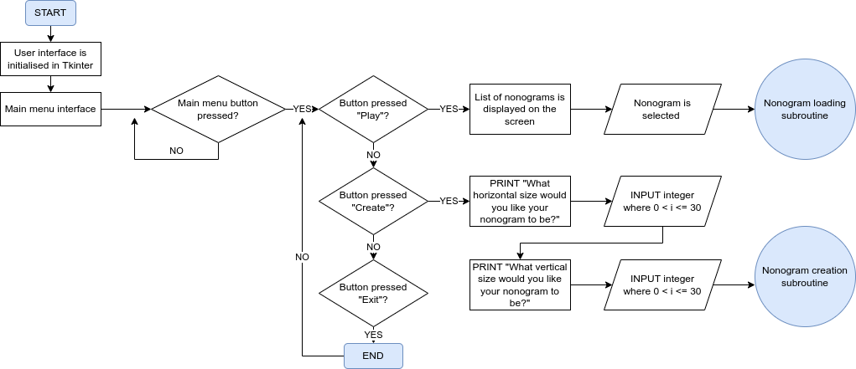
User interface
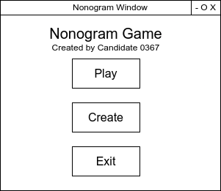
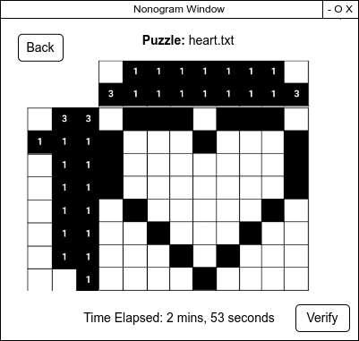
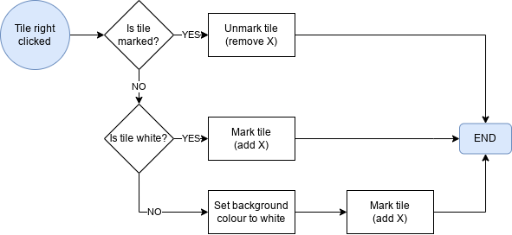

Key variables, data structures and classes
We will use one main nonogram array to store the contents of the nonogram loaded into memory. When the nonogram begins the process of initialisation, the horizontal and vertical hints will be loaded into two arrays named hintsHorizontal and hintsVertical. We will generate two variables named hintsHorizontalMinimum and hintsVerticalMinimum which will store the minimum amount of horizontal or vertical squares required to display the nonogram hints on screen.
The nonogram data structure will look like this:
# Puzzle used is puzzles/heart.txt
# Input:
> print(nonogram)
# Output:
['011101110', '100010001', '100000001', '100000001', '010000010', '001000100', '000101000', '000010000']
Each row of the nonogram puzzle will be stored as a value in the data structure. These values will store the individual integers (0 or 1) that make up each row. This is very important in the program as we will be using an interactive technique to load and manipulate the data structure rows and the user interface.

Regarding the creation aspect of the nonogram design puzzle, we will initialise a blank nonogram array and convert the users filled-in and blank cells of the user interface and appending them row by row to the master array, testing the background colour of each cell through an iterative process.

Test data to be used in iterative development process
There will be multiple sample puzzles for input and output. I have devised a series of nonograms to use for test data later on.
- heart.txt, a 9x8 nonogram in the shape of a heart. A generic nonogram puzzle.
- smiley.txt, a 7x8 nonogram in the shape of a smiley face. This nonogram has some completely empty rows and columns, which will be very important later for testing edge-cases in the debugging process.
- pixels.txt, a 9x9 nonogram. This puzzle has a lot of alternating digits and therefore the horizontal and vertical hints will contain a large amount of numbers. We can use this test data to ensure that the user interface is working correctly with a large number of hints.
- box.txt, a 4x4 nonogram. This is a nonogram that has a hole in the middle.
- small.txt, a 4x1 nonogram. This nonogram is not actually used for gameplay purposes, this will be used to test the error validation of the program to ensure a user does not try to load in a nonogram puzzle with a very small unsupported size.
- blank.txt,a 0x0 nonogram. This is also to test the data set validation.
Many of these data sets have individual characteristics designed to test all different aspects of the nonogram program design, such as the user interface displaying correctly with a large amount of hints, error validation, etc.

Implementation

Tkinter initialisation
As stated in the design, the final implementation will be using the Tkinter library, which is the de-facto Python library for designing graphical user interfaces. We will start with a main Python file and import the Tkinter library. We will ensure that the graphical user interface will display correctly by running some basic Tkinter code to effectively display a ‘Hello world’ program.
from tkinter import *
root = Tk()
# Title label widget
title = Label(root, text="Nonogram Project for OCR Computer Science")
title.pack()
root.mainloop()
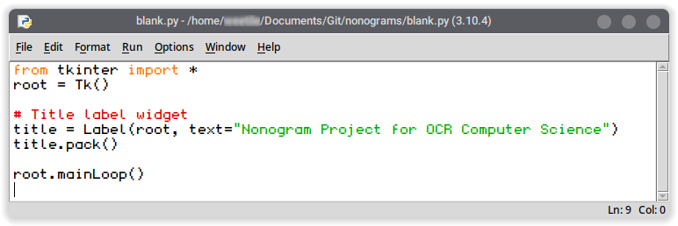
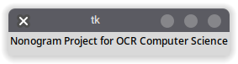
This works and we can confirm that the basic program is working. This will form the graphical component for the project and we can expand and build using this as a basis to fulfil the criteria for the stakeholder. Instead of continuing work on the graphical user interface right away, work should be prioritised on the backend first, which consists of importing necessary libraries, inputting and interpreting the test data to use through an iterative algorithm, and generating row and column hints for the nonogram puzzle based on said test data. The frontend can then be built at the end, after the essentials are done.

Backend
The program is composed of the backend and the frontend. The backend should consist of the following:
- Input for reading nonograms from text file
- Output for writing nonograms into text file
- Generating horizontal and vertical hints from nonogram
The frontend would consist of the following:
- Main menu
- Nonogram gameplay window with puzzle and ‘validate’ button
- Input fields for selecting nonogram puzzle
- Nonogram creation screen

Inputting test data for the iterative development process
The test data that we are using for the development process will be this basic 9x8 nonogram puzzle of a heart, as shown earlier. It is stored in a file named heart.txt in the root project directory.
# Contents of the heart.txt file
011101110
100010001
100000001
100000001
010000010
001000100
000101000
000010000
Using Python, we can use a subroutine to load in this nonogram as an array within our project file, as this will be needed for initialising the user interface later. The easy way would be to hardcode this in the program, however this would not allow us to dynamically swap out nonograms which is important for the nonogram creation aspect of the program.

An input/output function is called within Python to read the text file as an array. A blank nonogram array is created as a template for the data structure. We can use a simple Python call to open a file, and we are using append, which is a method of the array class, allowing us to add each line to the rear of the data structure.
filename = "heart.txt"
with open(filename) as file_in:
nonogram = []
for line in file_in:
nonogram.append(line)
print(nonogram) # For debugging/output purposes
By running this section of code, we get the following output:
['011101110\n', '100010001\n', '100000001\n', '100000001\n', '010000010\n', '001000100\n', '000101000\n', '000010000\n']

The only issue with this is that the whitespace/newline characters are appearing at the end of each array element, so we need to use the rstrip() method to solve this. We can replace this section of code:
nonogram.append(line) # Old code

nonogram.append(line.rstrip('\n')) # New code
The program now works correctly and this is the new output of the program.
['011101110', '100010001', '100000001', '100000001', '010000010', '001000100', '000101000', '000010000']

A very important part of the user interface is the nonogram hints/key that appears in the rows and the columns of the main puzzle. Since the nonogram is represented using a bottom-up approach as explained and justified in the design choices section for monogram data representation, we will need to generate the key using an iterative routine.

Generating row hints
We will create a new blank array to store the horizontal (row) hints. Since the nonogram array is stored in sets of rows, this should be easy to iterate through as each iteration would be through a new value/row in the dataset. We can perform a test to ensure a basis for our interactive routine and to make sure we can access each box of the nonogram individually.
for row in nonogram:
for value in row:
print(value)
The success criteria for this test is that each individual value (e.g: 0 or 1) will appear on a new line of the output. The reason for doing this is to ensure we can manipulate the individual puzzle on a value-per-value basis.
0
1
1
1
0
1
1
1
0
1
0
0
0
1
0
0
0
1
1
...

Since the test was a success and we have validated that the values would output correctly, we can begin generating the hints to the nonogram data structure. Within the nonogram data structure, the nonogram hints represent the number of consecutive filled-in boxes.
We must check per row how many sets of consecutive boxes there are, and store the value of consecutive boxes for each row. My initial idea is to use a count variable which will increment as each ‘1’ is detected. It will keep incrementing every time it is iterated with a value of ‘1’, but when a value of ‘0’ is detected, the counter will append itself to a new rowHints array, which at the end of the row is appended to the horizontalHints array. The reason for needing a separate rowHints array is that there will not always be one single set of consecutive boxes, there may be multiple, and storing each hint within a single row array will make it much easier to implement in the graphical user interface later on.
for row in nonogram: # Iterate through each row
for value in row: # Iterate through each value within row
consecutiveCount = 0 # For every row, reset consecutiveCount to 0
if value == "1":
consecutiveCount += 1 # Count is incremented per filled-in box
elif value == "0":
hintsHorizontal.append(consecutiveCount) # Count is appended...
consecutiveCount = 0 # ...and then reset.
print(hintsHorizontal) # For debugging/output purposes
Each row will reset the consecutive count to zero. If the value is set to “1”, the consecutive count is incremented. We will perform another test by checking the output of the hintsHorizontal array. If the code has worked as intended, the output should end up as this: [[3,3],[1,1,1],[1,1],[1,1],[1,1],[1,1],[1,1],[1]]. The output is:
[0, 0, 0, 0, 0, 0, 0, 0, 0, 0, 0, 0, 0, 0, 0, 0, 0, 0, 0, 0, 0, 0, 0, 0, 0, 0, 0, 0, 0, 0, 0, 0, 0, 0, 0, 0, 0, 0, 0, 0, 0, 0, 0, 0, 0, 0, 0, 0, 0, 0, 0, 0]
This is not the correct output, meaning a logic error was made. My first instinct was to assume that the if value == “1” condition was not being met, however by inserting a test print statement right after to check this, this isn’t the case.
I then realised that the consecutiveCount variable is being reset after every value instead of after every row, which is a logic mistake as we are testing the consecutive count per row.
for row in nonogram: # Iterate through each row
consecutiveCount = 0 # For every row, reset consecutiveCount to 0
for value in row: # Iterate through each value within row
if value == "1":
consecutiveCount += 1 # Count is incremented per filled-in box
print(consecutiveCount)
elif value == "0":
hintsHorizontal.append(consecutiveCount) # Count is appended...
consecutiveCount = 0 # ...and then reset.
print(hintsHorizontal) # For debugging/output purposes
By altering the code to change where the consecutiveCount = 0 occurs, the algorithm should now not reset the count every single iteration. Output:
[0, 3, 3, 1, 0, 0, 1, 0, 0, 1, 0, 0, 0, 0, 0, 0, 1, 0, 0, 0, 0, 0, 0, 0, 1, 0, 0, 0, 0, 1, 0, 0, 1, 0, 0, 1, 0, 0, 0, 0, 1, 1, 0, 0, 0, 0, 0, 0, 1, 0, 0, 0]
This is better, however the value ‘0’ should not be appended at all. We can try to stop this by preventing the consecutiveCount from appending if it has a value below one.
elif value == "0":
if int(consecutiveCount) > 0: # Test to see if > 0
rowHints.append(consecutiveCount) # Count is appended...
consecutiveCount = 0 # ...and then reset.
By adding this second line, the issue of having blank values appended should be resolved the next time the code is run. Output:
[3, 3, 1, 1, 1, 1, 1, 1, 1, 1, 1, 1, 1]
The next thing to fix is storing each row in the array, rather than each individual value. The following code is the final code I used to solve it:
# Algorithm below is to generate the horizontal key/hints for the current puzzle
hintsHorizontal = []
for row in nonogram: # Iterate through each row
consecutiveCount = 0 # For every row, reset consecutiveCount to 0
rowHints = []
for value in row: # Iterate through each value within row
if value == "1":
consecutiveCount += 1 # Count is incremented per filled-in box
elif value == "0":
if int(consecutiveCount) > 0: # Test to see if > 0
rowHints.append(consecutiveCount) # Count is appended...
consecutiveCount = 0 # ...and then reset.
hintsHorizontal.append(rowHints)
print(hintsHorizontal) # For debugging/output purposes
Instead of the count being appended directly to the hintsHorizontal array, it goes through an intermediate rowHints array. This joins each row together in the data structure, meaning when the GUI is initialised, extra code is not required to check what value corresponds to what row. The output is:
[[3, 3], [1, 1], [1], [1], [1, 1], [1, 1], [1, 1], [1]]
The final problem I noticed is sometimes, the value would not be appended. This is because if the last number in each row was a 1, the count would be incremented but it would not have a chance to be appended, as a value is only appended when there is a zero in the value after it. The value needs to be appended:
- when there is a change in value (e.g: 1 to a 0)
- at the end of each row regardless
However, we only have a condition for the first one. The second condition can be implemented by adding the following lines in bold (fourth to last line and third to last line):
# Algorithm below is to generate the horizontal key/hints for the current puzzle
hintsHorizontal = []
for row in nonogram: # Iterate through each row
consecutiveCount = 0 # For every row, reset consecutiveCount to 0
rowHints = []
for value in row: # Iterate through each value within row
if value == "1":
consecutiveCount += 1 # Count is incremented per filled-in box
elif value == "0":
if int(consecutiveCount) > 0: # Test to see if > 0
rowHints.append(consecutiveCount) # Count is appended...
consecutiveCount = 0 # ...and then reset.
if consecutiveCount > 0: # JUST IN CASE the last value of a row is a 1
rowHints.append(consecutiveCount) # Gives it a chance to be appended
hintsHorizontal.append(rowHints)
print(hintsHorizontal) # For debugging/output purposes
The output from this code is:
[[3, 3], [1, 1, 1], [1, 1], [1, 1], [1, 1], [1, 1], [1, 1], [1]]
The code is now correctly functioning, and as it is an iterative routine through a dynamic process, it should work no matter the size of the nonogram puzzle. These hints match up with that of the test data.

Generating horizontal minimum squares
One last thing to do is to make a new variable to represent the minimum number of horizontal squares necessary to display all of the nonogram hints. This will be very important when creating the graphical user interface, as the total number of grid rows needed will be:
number of rows in the nonogram puzzle + minimum number of horizontal squares to represent hint
For the heart nonogram, this would be 9 (number of rows of puzzle) + 3 (minimum number of horizontal squares to represent hints), meaning the graphical user interface needs to display 12 rows. The first three rows will be immutable, and will not respond to user input. They will also have the unique attribute of having a number inside them, which is different to the main portion of the puzzle.
Using the test data of the heart nonogram, we are expecting a value of 3 as that is exactly how many columns the row hints take up.
hintsHorizontalMinimum = 0
for row in hintsHorizontal:
count = 0
for hint in row:
count += 1
if count > hintsHorizontalMinimum:
hintsHorizontalMinimum = count
print(hintsHorizontalMinimum)
This section of code will iterate through each row of the hints, and increment count for every value in the row. The count resets every row iteration, so the output should just be the greatest number of hints that an individual row in the array has.
Output:
3

Generating column hints
The row hints themselves are defined in the array hintsHorizontal, and the number of squares needed to properly display them is stored in the variable hintsHorizontalMinimum.
We still need counterparts for these to represent the columns. We will have a similarly named array and variable called hintsVertical and hintsVerticalMinimum.
The code used for the horizontal hints can be adapted for the vertical hints, however there will need to be some modifications.
for i in range(len(nonogram[0])): # Iterating column
consecutiveCount = 0 # For every column, reset consecutiveCount to 0
columnHints = []
for j in range(len(nonogram[i])): # Iterating number in column
if nonogram[j][i] == "1":
consecutiveCount += 1
elif nonogram[j][i] == "0":
if int(consecutiveCount) > 0: # Test to see if > 0
columnHints.append(consecutiveCount) # Count is appended...
consecutiveCount = 0 # ...and then reset.
if consecutiveCount > 0: # JUST IN CASE the last value of a column is a 1
columnHints.append(consecutiveCount) # Gives it a chance to be appended
hintsVertical.append(columnHints)

This code gave the following error:
===== RESTART: /home/CANDIDATE/Documents/Git/nonograms/main.py =====
====================================================================
Nonograms by Candidate 0367 for OCR A Level Computer Science 2022
====================================================================
Nonogram data structure = ['011101110', '100010001', '100000001', '100000001', '010000010', '001000100', '000101000', '000010000']
hintsHorizontal = [[3, 3], [1, 1, 1], [1, 1], [1, 1], [1, 1], [1, 1], [1, 1], [1]]
hintsHorizontalMinimum = 3
Traceback (most recent call last):
File "/home/weetile/Documents/Git/nonograms/main.py", line 62, in <module>
if nonogram[j][i] == "1":
IndexError: list index out of range
I realised the mistake was the program was iterating through the length of a column in line 4 of the code snippet rather than the length of a row, so I removed the [i] within the ‘for j in range(len(nonogram[i])): # Iterating number in column’.
This caused the program to operate correctly.
The finished code is:

# Algorithm below is to generate the vertical key/hints for the current puzzle
hintsVertical = []
for i in range(len(nonogram[0])): # Iterating column
consecutiveCount = 0 # For every column, reset consecutiveCount to 0
columnHints = []
for j in range(len(nonogram)): # Iterating number in column
if nonogram[j][i] == "1":
consecutiveCount += 1
elif nonogram[j][i] == "0":
if int(consecutiveCount) > 0: # Test to see if > 0
columnHints.append(consecutiveCount) # Count is appended...
consecutiveCount = 0 # ...and then reset.
if consecutiveCount > 0: # JUST IN CASE the last value of a column is a 1
columnHints.append(consecutiveCount) # Gives it a chance to be appended
hintsVertical.append(columnHints)
print("hintsVertical = " + str(hintsVertical))

Output:
[[3], [1, 1], [1, 1], [1, 1], [1, 1], [1, 1], [1, 1], [1, 1], [3]]

Generating vertical minimum squares
We can use the exact same algorithm as was used for generating the minimum number of horizontal square hints. The only thing that will need to be changed are the variable/array names.
# Code to generate the minimum number of squares to represent the column hints
# This will be very important later for the GUI grid size
hintsVerticalMinimum = 0
for column in hintsVertical:
count = 0
for hint in column:
count += 1
if count > hintsVerticalMinimum:
hintsVerticalMinimum = count
print(hintsVerticalMinimum)
This generates the correct output of:
2

Backend validation
This forms the majority of the backend of the project.
To ensure that the algorithms are working correctly, I have decided to include some debugging utilities in the code through a variable flag that I can toggle on/off.
debug = True
...
if debug == True:
print("Nonogram data file = " + filename)
print("Nonogram data structure = " + str(nonogram))
...
if debug == True:
print("hintsHorizontal = " + str(hintsHorizontal))
...
if debug == True:
print("hintsHorizontalMinimum = " + str(hintsHorizontalMinimum))
...
if debug == True:
print("hintsVertical = " + str(hintsVertical))
...
if debug == True:
print("hintsVerticalMinimum = " + str(hintsVerticalMinimum))

This nicely generates a debugging screen with all of the backend information on it. For example, for the heart.txt dataset I have been using up until this point, the output with debug set to True would be:
Nonogram data file = puzzles/heart.txt
Nonogram data structure = ['011101110', '100010001', '100000001', '100000001', '010000010', '001000100', '000101000', '000010000']
hintsHorizontal = [[3, 3], [1, 1, 1], [1, 1], [1, 1], [1, 1], [1, 1], [1, 1], [1]]
hintsHorizontalMinimum = 3
hintsVertical = [[3], [1, 1], [1, 1], [1, 1], [1, 1], [1, 1], [1, 1], [1, 1], [3]]
hintsVerticalMinimum = 2

These debugging features will not be visible to the end user and are simply used for ensuring validation in the development cycle. To be certain that the program is functioning correctly up until this point, and has the functionality of being able to input the nonogram puzzle from a text file as an array, generate both horizontal and vertical hints with corresponding minimum numbers, I have decided to send a series of tests with custom nonograms to my stakeholder Adam to make sure that he is happy with how the nonograms are being parsed.

Puzzle name | Puzzle size (horizontal x vertical) | Imports  correct as array? | hintsHorizontal correct? | hintHorizontalMinimum correct? | hintsVertical correct? | hintsVerticalMinimum correct?
heart.txt | 9x8 | Yes ✅ | Yes ✅ | 3 ✅ | Yes ✅ | 2 ✅
box.txt | 4x4 | Yes ✅ | Yes ✅ | 2 ✅ | Yes ✅ | 2 ✅
smiley.txt | 7x7 | Yes ✅ | Yes ✅ | 2 ✅ | Yes ✅ | 2 ✅
pixels.txt | 9x9 | Yes ✅ | Yes ✅ | 5 ✅ | Yes ✅ | 5 ✅

This is a success. As shown from the results of the various tests that were conducted, all of the information seems to match up with the metadata before they were imported into the program. The current code of the program up until this point is as follows on the next page:
print("=================================================================")
print("Nonograms by Candidate 0367 for OCR A Level Computer Science 2022")
print("=================================================================")
filename = "puzzles/heart.txt" # Relative .txt file to be loaded
debug = True # NOT VISIBLE TO END USER, for development output only!
# DATA STRUCTURE SECTION 1:
# Basic input of the nonogram text file into an array
with open(filename) as file_in:
nonogram = [] # Initialises blank nonogram
for line in file_in: # Iterates through each line in the file...
nonogram.append(line.rstrip('\n')) # Calls rstrip function to remove line breaks and /n
if debug == True:
print("Nonogram data file = " + filename + "\n") # Debug: prints relative data file
print("Nonogram data structure = " + str(nonogram) + "\n") # Debug: prints the actual data structure array
# STRUCTURE SECTION 2:
# Algorithm below is to generate the horizontal key/hints for the current puzzle
hintsHorizontal = []
for row in nonogram: # Iterate through each row
consecutiveCount = 0 # For every row, reset consecutiveCount to 0
rowHints = []
for value in row: # Iterate through each value within row
if value == "1":
consecutiveCount += 1 # Count is incremented per filled-in box
elif value == "0":
if int(consecutiveCount) > 0: # Test to see if > 0
rowHints.append(consecutiveCount) # Count is appended...
consecutiveCount = 0 # ...and then reset.
if consecutiveCount > 0: # JUST IN CASE the last value of a row is a 1
rowHints.append(consecutiveCount) # Gives it a chance to be appended
hintsHorizontal.append(rowHints)
if debug == True:
print("hintsHorizontal = " + str(hintsHorizontal)) # For debugging/output purposes
# Code to generate the minimum number of squares to represent the row hints
# This will be very important later for the GUI grid size
hintsHorizontalMinimum = 0
for row in hintsHorizontal:
count = 0
for hint in row:
count += 1
if count > hintsHorizontalMinimum:
hintsHorizontalMinimum = count
if debug == True:
print("hintsHorizontalMinimum = " + str(hintsHorizontalMinimum)) # For debugging/output purposes
# STRUCTURE SECTION 3:
# Algorithm below is to generate the vertical key/hints for the current puzzle
hintsVertical = []
for column in range(len(nonogram[0])): # Iterating column
consecutiveCount = 0 # For every column, reset consecutiveCount to 0
columnHints = []
for value in range(len(nonogram)): # Iterating number in column
if nonogram[value][column] == "1":
consecutiveCount += 1 # Consecutive count is incremented by one
elif nonogram[value][column] == "0":
if int(consecutiveCount) > 0: # Test to see if > 0
columnHints.append(consecutiveCount) # Count is appended...
consecutiveCount = 0 # ...and then reset.
if consecutiveCount > 0: # JUST IN CASE the last value of a column is a 1
columnHints.append(consecutiveCount) # Gives it a chance to be appended
hintsVertical.append(columnHints)
if debug == True:
print("hintsVertical = " + str(hintsVertical)) # For debugging/output purposes
# Code to generate the minimum number of squares to represent the column hints
# This will be very important later for the GUI grid size
hintsVerticalMinimum = 0
for column in hintsVertical:
count = 0
for hint in column:
count += 1
if count > hintsVerticalMinimum:
hintsVerticalMinimum = count
if debug == True:
print("hintsVerticalMinimum = " + str(hintsVerticalMinimum)) # For debugging/output purposes

Frontend
from tkinter import *
root = Tk() # Initialise Tk root
frame = Frame(root) # Base frame
frame.grid(row=0, column=0, sticky="news")
root.title('Nonograms') # Sets window title to 'Nonograms'
root.iconbitmap("@icon.xbm") # Sets basic window icon
grid = Frame(frame) # Grid frame
grid.grid(sticky="news", column=0, row=0, columnspan=1)
for x in range(len(nonogram[0]) + hintsHorizontalMinimum): # Iterating through row...
for y in range(len(nonogram) + hintsVerticalMinimum): # Iterating through column...
button = Button(frame) # Define new button
button.grid(column=x, row=y, sticky="news") # Assign button to grid
root.mainloop()

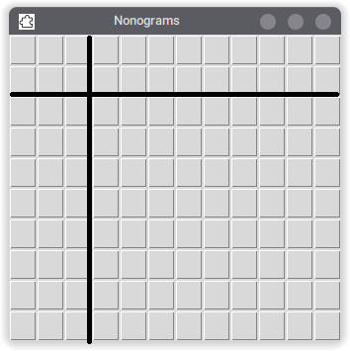
This portion of code initialises a blank array of buttons of len(nonogram[0]) + hintsHorizontalMinimum horizontal length and len(nonogram) + hintsVerticalMinimum vertical height. These variables have already been defined for us in the backend so we don’t need to worry about them now and can safely call them in the program. Using the hearts.txt data set, running the program displays this:

The blank lines are drawn onto the image as an annotation and are not part of the program itself. The bottom right section represents the mutable section of the program, the buttons that are interacted with by the user. The goal is to have the background colour of the buttons toggle between black and white when clicked, representing a ‘1’ or a ‘0’ in the nonogram array data structure.
All other sections should be immutable after the nonogram is loaded in.

Toggling between button states
We need some code to toggle between the different button states of the program. The code in bold indicates the new additions.
def toggle():
if button.cget("bg") == "white":
button.configure(bg="black")
elif button.cget("bg") == "black":
button.configure(bg="white")
else:
print("Error")
for x in range(len(nonogram[0]) + hintsHorizontalMinimum):
for y in range(len(nonogram) + hintsVerticalMinimum):
button = Button(frame, bg="white", command = toggle)
button.grid(column=x, row=y, sticky="news")
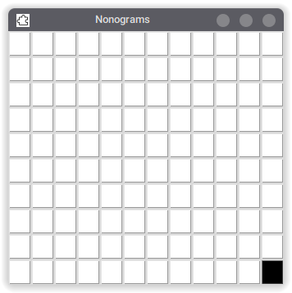
A subroutine can be defined to change the background colour of the button. This will allow the user to mark the cells in black or white as they are completing the nonogram puzzle. However, when I ran this code, the background would only change for the bottom right button no matter what I did. The specific button wasn’t being parsed properly and it was just changing the background attribute of the last button to be initialised.

def toggle(event): # Event to toggle BG colour when button is pressed
button = event.widget # Passing through button to subroutine
if button.cget("bg") == "white": # If the button is white...
button.configure(bg="black",activebackground="black") # ...set colour to black
elif button.cget("bg") == "black": # If the button is black...
button.configure(text="") # ...empty text in case of mark
button.configure(bg="white",activebackground="white") # ... set colour to white
else:
pass
for x in range(len(nonogram[0]) + hintsHorizontalMinimum):
for y in range(len(nonogram) + hintsVerticalMinimum):
button = Button(frame, bg="white")
button.grid(column=x, row=y, sticky="news")
button.bind("<Button-1>", toggle)

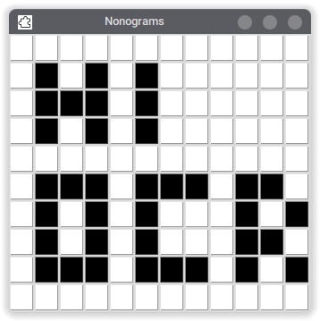
By parsing the button itself to the subroutine, we are able to modify the background colour of any of the specific buttons that are clicked. They will toggle between the black and white colour state. I have also adjusted the activebackground attribute to ensure that the colour remains the same even when the mouse hovers above it.

Defining immutable cells
The next thing to do is define the immutable cells. We can very cleverly do this by changing the definition of the buttons themselves. See in bold below:
for x in range(len(nonogram[0]) + hintsHorizontalMinimum): # Iterate per row...
for y in range(len(nonogram) + hintsVerticalMinimum): # Iterate per column...
button = Button(frame, bg="white") # Initialise a new button...
button.grid(column=x, row=y, sticky="news") # ...as part of grid
if x >= hintsHorizontalMinimum and y >= hintsVerticalMinimum:
print("Nothing")
else:
button.configure(bg="#f0f0f0")
button.bind("<Button-1>", toggle)

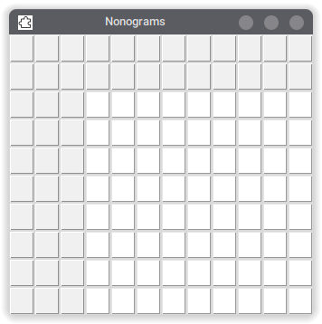
We are checking the x value of the nonogram array to ensure it is greater than or equal to the variable hintsHorizontalMinimum. We are checking the y value of the nonogram array to ensure it is greater than or equal to the variable hintsVerticalMinimum. This is so we can distinguish between the buttons that are part of the nonogram hints, and the buttons that the user should interact with.

The code works correctly, the cells that the user is supposed to interact with are now coloured white and all the other cells are coloured grey. We can even take this a step further, by deleting the unnecessary cells at the top left that do not contain any horizontal or vertical hints. To do this, we will remove all cells that do not satisfy the condition x < hintsHorizontalMinimum and y < hintsVerticalMinimum. This can be tested using an if statement, and we will use the method button.grid_forget() which is a method of the widget objects so we can safely remove them from the grid.

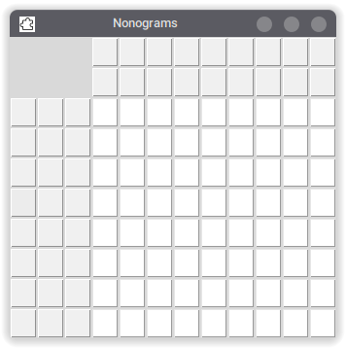
As you can see, the unnecessary/redundant cells at the top right have disappeared and we are left with only the essentials: the cells representing the horizontal hints, the vertical hints, and the interactive cells. Later, we will add the text from the horizontalHints and verticalHints arrays to the cells.
To ensure we have not made any mistakes with the frontend up until this point, we will conduct a series of tests with the sample test data.

Debugging the horizontal and vertical buttons
Puzzle name | Puzzle size (horizontal x vertical) | Nonogram loads to display | Unnecessary cells are removed | Horizontal hint size is correct | Vertical hint size is correct
heart.txt | 9x8 | Yes ✅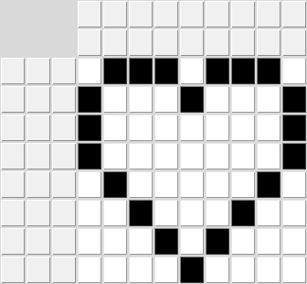 | Yes ✅ | Yes ✅ | Yes ✅
box.txt | 4x4 | Yes ✅  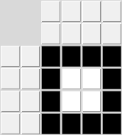 | Yes ✅ | Yes ✅ | Yes ✅
smiley.txt | 7x7 | Yes ✅  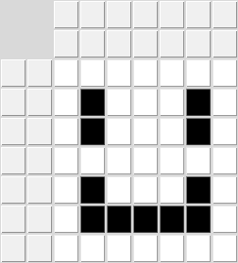 | Yes ✅ | Yes ✅ | Yes ✅
pixels.txt | 9x9 | Yes ✅  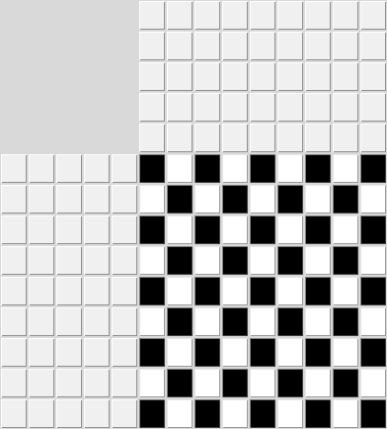 | Yes ✅ | Yes ✅ | Yes ✅
small.txt | 4x1 (unsupported size) | No 🚫 | No 🚫 | Yes ✅ | Yes ✅
blank.txt | 0x0 (empty) | No 🚫 | No 🚫 | No 🚫 | No 🚫

Luckily, most of the testing data went through correctly and produced a correct output. The only data that failed was the small.txt and empty.txt data sets, which was intentionally too small for it to draw properly on the screen. To quantify this mistake and account for validation, I have included this condition before section 2 of the code just after the array is initialised.
# Basic validation to make sure the nonogram has a minimum size of 2x2
if (len(nonogram) < 2 or len(nonogram[0]) < 2):
messagebox.showerror("Puzzle size error","Nonogram must have a minimum size of 2x2.\nThe loaded nonogram '" + filename + "' has a size of " + str(len(nonogram[0])) + "x" + str(len(nonogram)) + ".")
quit()
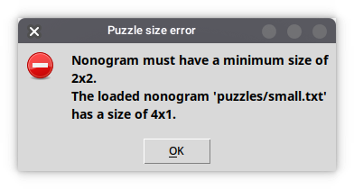
The if statement checks if the horizontal or vertical size of the nonogram is less than two. If it is, a Tkinter message box will display on the screen detailing the error to the user and the program will be terminated using the built-in quit() function. Now, if the user accidentally tries to load a nonogram that is either too small or empty, they will be notified and can select a new nonogram, and the program will terminate.

Filling in horizontal and vertical hints
The next stage to complete is filling in the horizontal and vertical hints for the nonogram puzzle. There are two iterative procedures which need to be used here, a horizontal procedure and a vertical procedure for the two separate sets of arrays. My first initial instinct was to simply copy the hint to the corresponding cell. This was the snippet of code I used:
if x < hintsHorizontalMinimum: # Selecting JUST the horizontal hints...
if (hintsHorizontalMinimum-x-1 < len(hintsHorizontal[y-hintsVerticalMinimum])): button.configure(text=hintsHorizontal[y-hintsVerticalMinimum][hintsHorizontalMinimum-x-1])

However, this produced a list index out of range error.
Traceback (most recent call last):
File "/home/weetile/Documents/Git/nonograms/main.py", line 140, in <module>
button.configure(text=hintsHorizontal[y-hintsVerticalMinimum][hintsHorizontalMinimum-x-1])
IndexError: list index out of range
This is because, in the hintsHorizontal array, there is not always a hint for every single square it is trying to copy from the array to the button. We must have a conditional if statement to ensure the horizontal index of the button is not greater than the length of the hints for the corresponding row. I modified and changed the code to include this conditional statement:
if x < hintsHorizontalMinimum: # Selecting JUST the horizontal hints...
if (hintsHorizontalMinimum-x-1 < len(hintsHorizontal[y-hintsVerticalMinimum])): # Only applying if in range button.configure(text=hintsHorizontal[y-hintsVerticalMinimum][hintsHorizontalMinimum-x-1]) # Setting the text to the correct hint

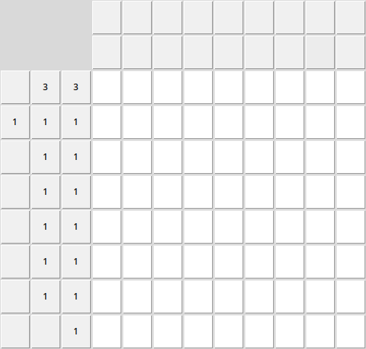
Now, the horizontal hints have been copied over and aligned correctly for the correct indexes. For the squares where there is not a required nonogram hint, I have skipped over those squares and left them blank.
However, it would be more obvious to the end-user if those squares had disappeared entirely, so we can use this conditional statement to remove them:
else: # If there is no text to set,
button.grid_forget() # remove the horizontal button.

This is the same method of the button widget that was used earlier for removing the redundant buttons at the top right of the screen.
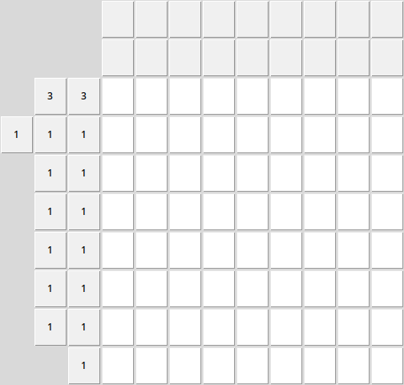

As you can see, the only buttons that exist in the horizontal pane are the horizontal hints necessary for gameplay. Since the hints are being loaded dynamically, it should not matter how tall the nonogram puzzle is; the puzzle can be of any size and it would still load in correctly.
We can use similar code for the vertical section:
if y < hintsVerticalMinimum: # Selecting JUST the vertical hints...
if (hintsVerticalMinimum-y-1 < len(hintsVertical[x-hintsHorizontalMinimum])): # Only applying if in range
button.configure(text=hintsVertical[x-hintsHorizontalMinimum][hintsVerticalMinimum-y-1]) # Setting the text to the correct hint
else: # If there is no text to set,
button.grid_forget() # remove the vertical button.

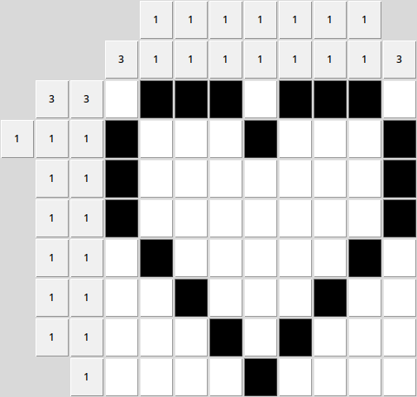
The end result is an almost entirely completed user interface. The horizontal and vertical hints are both represented correctly with all redundant buttons removed from the grid.
We will do another test to ensure that the user interface is working properly and the initialisation of each data set of the nonogram puzzle is a non-issue.

Debugging the correct horizontal and vertical hints

Puzzle name | Puzzle size (horizontal x vertical) | Nonogram loads to display | Unnecessary cells are removed | Horizontal hints display correctly | Vertical hints display correctly
heart.txt | 9x8 | Yes ✅ | Yes ✅ | Yes ✅ | Yes ✅
box.txt | 4x4 | Yes ✅  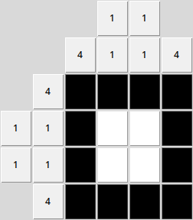 | Yes ✅ | Yes ✅ | Yes ✅
smiley.txt | 7x7 | Yes ✅  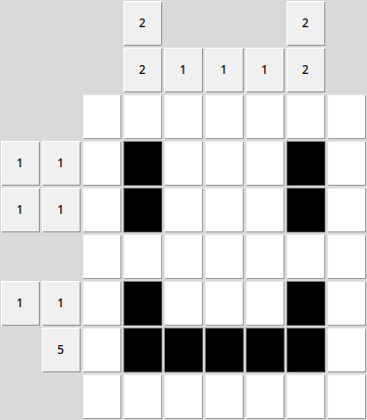 | No 🚫 | No 🚫 | No 🚫
pixels.txt | 9x9 | Yes ✅  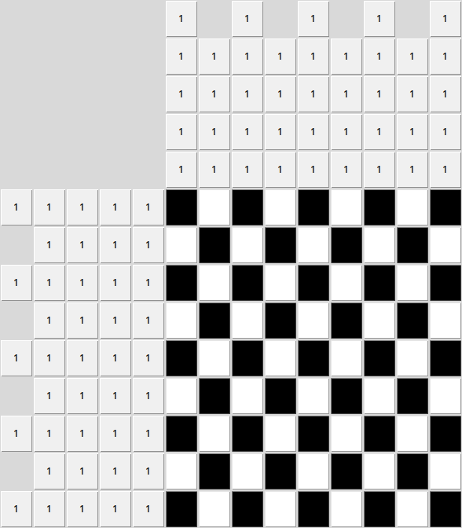 | Yes ✅ | Yes ✅ | Yes ✅
generic.txt | 10x10 | Yes ✅ | Yes ✅ | No 🚫 | No 🚫

Debugging empty row/columns
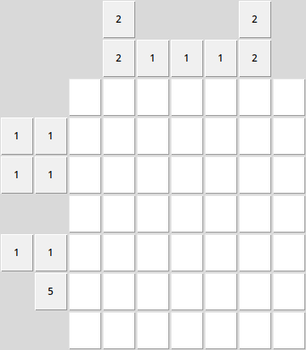
There is an issue here with our third set of test data. When we load this smiley nonogram, we can see that in the columns and rows that are completely empty there are no buttons at all. The intended behaviour is that any blank columns or rows will have a single ‘0’ button rather than the absence of buttons entirely.

To resolve this, I have added a small section of code to replace blank/rows and columns with a ‘0’. See the bold text on the code snippet below, there is a selection statement which tests the right-most row/bottom column and checks if it is completely blank. If it is, instead of deleting the button, it will instead set the text to “0”.

if x < hintsHorizontalMinimum: # Selecting JUST the horizontal hints...
if (hintsHorizontalMinimum-x-1 < len(hintsHorizontal[y-hintsVerticalMinimum])): # Only applying if in range
button.configure(text=hintsHorizontal[y-hintsVerticalMinimum][hintsHorizontalMinimum-x-1]) # Setting the text to the correct hint
else: # If there is no text to set,
if (hintsHorizontalMinimum-x-1 > 0): # If it is not the only button on that row,
button.grid_forget() # remove the horizontal button.
else:
button.configure(text="0") # Set to 0 otherwise
if y < hintsVerticalMinimum: # Selecting JUST the vertical hints...
if (hintsVerticalMinimum-y-1 < len(hintsVertical[x-hintsHorizontalMinimum])): # Only applying if in range
button.configure(text=hintsVertical[x-hintsHorizontalMinimum][hintsVerticalMinimum-y-1]) # Setting the text to the correct hint
else: # If there is no text to set,
if (hintsVerticalMinimum-y-1 > 0): # If it is not the only button on that column,
button.grid_forget() # remove the vertical button.
else:

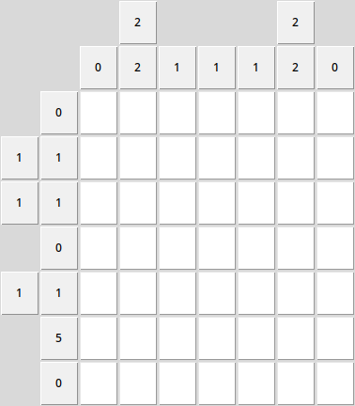
By using this debugging process, we have resolved this error and now the blank columns and rows are displaying correctly. This representation in Tkinter looks near-identical to a traditional representation that an end user is used to within existing nonogram solutions.
Performing this test has also led me to realise the hints were arranged in the reverse order.
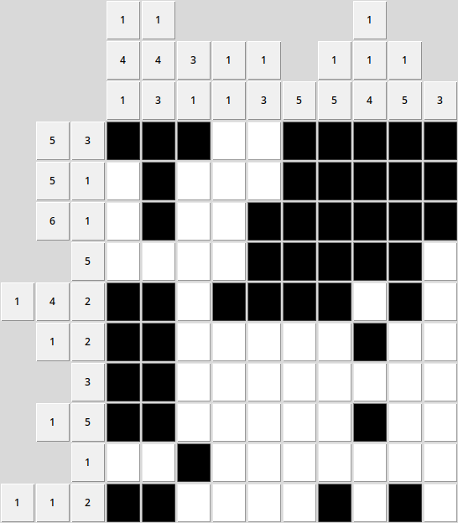
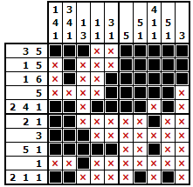

There is an error when the cell text is being loaded in from the arrays and the wrong text is being inputted back to front. For example, on the fifth row, the nonogram hint is meant to read “2 4 1” while on my program, it has loaded in the reverse as “1 4 2”.

The two lines of code used to configure the text for the horizontal and vertical rows were:
button.configure(text=hintsHorizontal[y-hintsVerticalMinimum][hintsHorizontalMinimum-x-1])
...
button.configure(text=hintsVertical[x-hintsHorizontalMinimum][hintsHorizontalMinimum-y-1])
Conducting these tests has made me realise that the second index (highlighted in bold) was incorrect, as it was assigning the hints in reverse order. The correct code is:
button.configure(text=hintsHorizontal[y-hintsVerticalMinimum][x-hintsHorizontalMinimum]) # Setting the text to the correct hint
...
button.configure(text=hintsVertical[x-hintsHorizontalMinimum][y-hintsVerticalMinimum]) # Setting the text to the correct hint

This code now allows the nonogram hints to draw correctly, when they were previously being drawn in reverse order by accident.
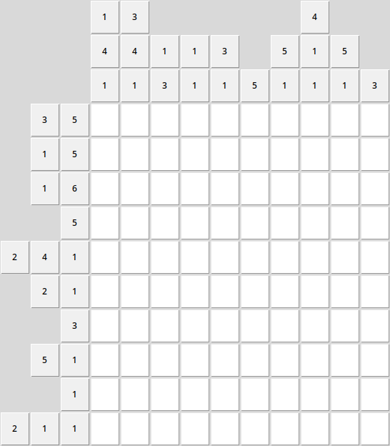

Final section code
Below is the final code with all of the improvements and modifications from the debugging stages.

if x < hintsHorizontalMinimum: # Selecting JUST the horizontal hints...
if (hintsHorizontalMinimum-x-1 < len(hintsHorizontal[y-hintsVerticalMinimum])): # Only applying if in range
button.configure(text=hintsHorizontal[y-hintsVerticalMinimum][hintsHorizontalMinimum-x-1]) # Setting the text to the correct hint
else: # If there is no text to set,
if (hintsHorizontalMinimum-x-1 > 0): # If it is not the only button on that row,
button.grid_forget() # remove the horizontal button.
else:
button.configure(text="0") # Set to 0 otherwise
if y < hintsVerticalMinimum: # Selecting JUST the vertical hints...
if (hintsVerticalMinimum-y-1 < len(hintsVertical[x-hintsHorizontalMinimum])): # Only applying if in range
button.configure(text=hintsVertical[x-hintsHorizontalMinimum][y-hintsVerticalMinimum]) # Setting the text to the correct hint
else: # If there is no text to set,
if (hintsVerticalMinimum-y-1 > 0): # If it is not the only button on that column,
button.grid_forget() # remove the vertical button.
else:
button.configure(text="0") # Set to 0 otherwise
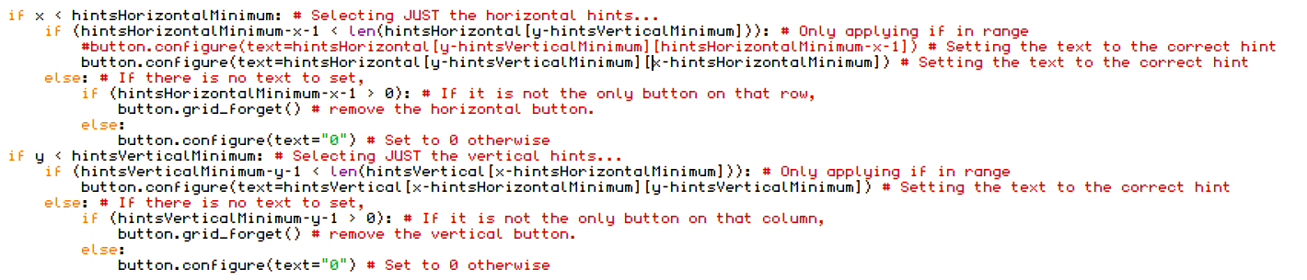

Nonogram marking
One important part of the nonogram program is the ability to ‘mark’ certain cells which are to be left blank throughout. This allows the user to employ a ‘divide and conquer’ approach when it comes to completing the puzzle. This is functionally identical to the ‘flags’ in Minesweeper, where the user right-clicks to mark a tile as ‘safe’ from containing a mine.
We will aim to implement a system based on the following design.
I.e: If the tile is already white, it will simply toggle between an X or no X. If the tile is black however, it will set the colour to white and add an X.
To do this, we can modify our button definition to call to a new function when the right mouse button is pressed.
button.bind("<Button-1>", toggle) # When the left mouse button is pressed, call the toggle function
button.bind("<Button-3>", mark) # When the right mouse button is pressed, call the mark function

Earlier in the program where we have defined the first subroutine ‘toggle’, we will include a similar subroutine definition below.

def toggle(event): # Event to toggle BG colour when button is pressed
button = event.widget # Passing through button to subroutine
if button.cget("bg") == "white": # If the button is white...
button.configure(text="") # ...empty text in case of mark
button.configure(bg="black",activebackground="#0d0d0d") # ...set colour to black
elif button.cget("bg") == "black": # If the button is black...
button.configure(bg="white",activebackground="#f0f0f0") # ... set colour to white
else:
pass
def mark(event): # Event to mark the cell with an X
button = event.widget # Passing through button to subroutine
if button.cget("bg") == "black":
button.configure(bg="white",activebackground="#f0f0f0")
button.configure(text="X")
elif button.cget("bg") == "white":
if button.cget("text") == "X":
button.configure(text="")
else:
button.configure(text="X")
Running the program, we can now toggle between filled-in and blank states using the left mouse button and mark any tile we want using the right mouse button.
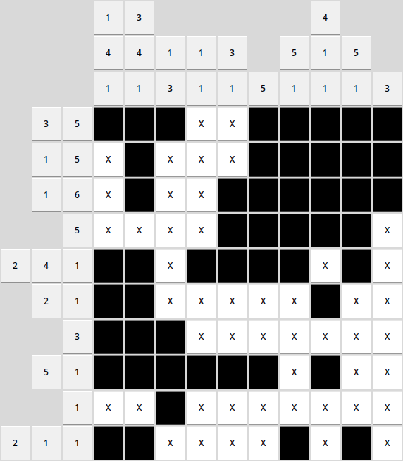

Making user interface more accessible
One of my next goals is making the user interface more accessible to the user. Not only does this increase usability, but we will need to implement a ‘verify button’ before the nonogram program could be considered completed.
Pertaining to the user interface as specified in the Design section, we should add some labels to the program. I used the following code to add a label but this gave me an output of this:
grid = Frame(frame) # Grid frame
grid.grid(sticky="news", column=0, row=0, columnspan=1)
label = Label(frame, text="Nonogram Program by Candidate 0367")
label.grid(row=0)
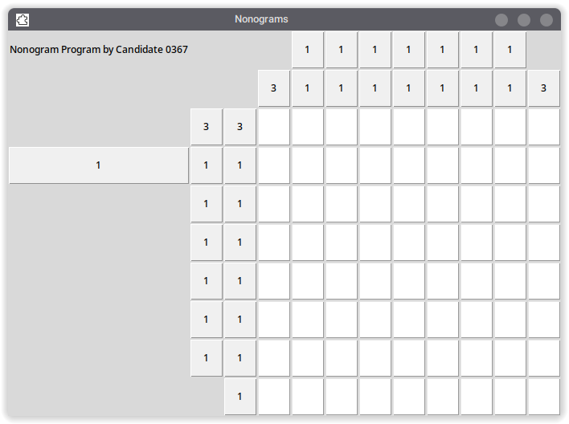
There is an issue with how the elements are positioned and designed in Tkinter. Currently, the labels and the buttons are occupying the same frame under the root. We can fix this issue by modifying where the buttons in the earlier section are drawn.
for x in range(len(nonogram[0]) + hintsHorizontalMinimum): # Iterate per row...
for y in range(len(nonogram) + hintsVerticalMinimum): # Iterate per column...
button = Button(grid, width="2",height="2", bg="white") # Initialise a new button...
button.grid(column=x, row=y, sticky="news") # ...as part of grid
This is the section of code that pertains to the drawing of buttons on the graphical user interface. By changing the button root from ‘frame’ to ‘grid’ (see bold), we should be able to draw the buttons within a grid within the frame so we can easily add other user interface elements.
We will also modify the padx and pady variables of the grid to add some slight borders around the button grid so that it is not touching the edges of the window directly.
One last thing to also do is ensure the row attribute of the label is lower than the row attribute of the grid, so that the text appears at the top of the screen.
grid = Frame(frame) # Grid frame
grid.grid(sticky="news", column=0, row=1, columnspan=1, padx=(10,10),pady=(10,10))
label = Label(frame, text="Nonogram Program by Candidate 0367")
label.grid(row=0)

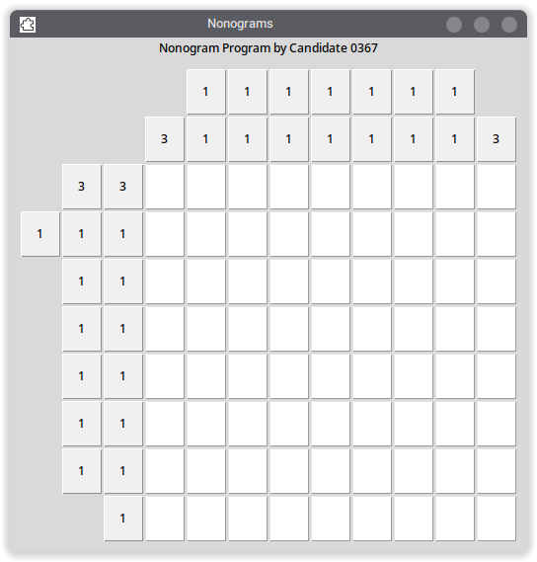
This is the user interface design as conceptualised earlier during the Design stage.
It would be useful to display the currently active puzzle at the top of the screen, with a way for the user to see how long they have spent on the nonogram puzzle. I will make the label that we just defined more useful by displaying the current puzzle instead of static text.

Verify solution
Perhaps the most important aspect of the program is being able to verify the solution of the puzzle. The user will need a way to compare their attempted solution of the puzzle to the real nonogram answer key.
Here is some code that allows us to add to an additional ‘Verify’ button at the bottom of our nonogram user interface:
verifyButton = Button(frame,text="Verify",command=verify)
verifyButton.grid(row=4,column=1,padx=(10,10),pady=(10,10))
This new button will execute the subroutine verify when the button is pressed.
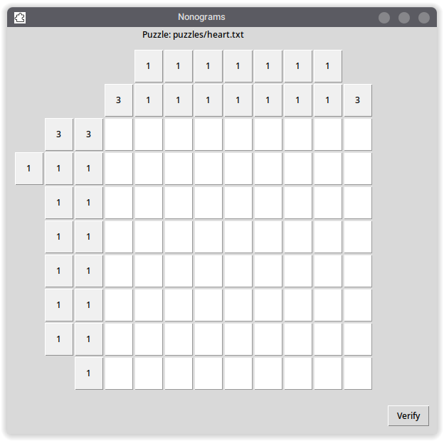
As shown, the button now appears at the bottom-right of the nonogram puzzle user interface.
The button currently doesn’t do anything as we haven’t defined verify as a subroutine yet. As explained in the Design section, the verify procedure will convert which boxes the user has filled-in into an array, which will be checked against the original nonogram array from the backend.

There is one issue with implementing this as it stands. Each time a new instance of the button is made, it is essentially ‘overwriting’ the reference to the button, so there is no way to reference the button afterwards.

The solution is to modify the initialisation of the buttons to have them appended to a row array, which is then appended to a master button array, very similar to how the nonogram hints were initialised in the backend of the application in the first place.

for x in range(len(nonogram[0]) + hintsHorizontalMinimum): # Iterate per row...
for y in range(len(nonogram) + hintsVerticalMinimum): # Iterate per column...
button = Button(grid, width="2",height="2", bg="white") # Initialise a new button...
button.grid(column=x, row=y) # ...as part of grid
if x < hintsHorizontalMinimum and y < hintsVerticalMinimum: # If the button is in the top left corner (redundant)...
button.grid_forget() # Forget the buttons on the grid
if x >= hintsHorizontalMinimum and y >= hintsVerticalMinimum:
pass # Do nothing, this section of code was useful for debugging purposes
else:
button.configure(bg="#f0f0f0") # Set to default BG colour

This is the current code as it stands. The code functions for creating the buttons, however in the process, we are losing the reference to the button as it is being continually overwritten.
We need to still be able to reference the button as during our verify algorithm, as we will be iterating through the set of buttons both horizontally and vertically to begin reconstructing the user’s solution back into an array.
Instead of setting the variable button to the reference of the last button to be created, we could append a button to the master array every time a button is initialised, allowing us to reference it by horizontal and vertical value. (See code in bold)
buttonArray = []
for x in range(len(nonogram[0]) + hintsHorizontalMinimum): # Iterate per row...
rowButtonArray = []
for y in range(len(nonogram) + hintsVerticalMinimum): # Iterate per column...
button = Button(grid, width="2",height="2", bg="white") # Initialise a new button...
button.grid(column=x, row=y) # ...as part of grid
rowButtonArray.append(button)
if x < hintsHorizontalMinimum and y < hintsVerticalMinimum: # If the button is in the top left corner (redundant)...
button.grid_forget() # Forget the buttons on the grid
if x >= hintsHorizontalMinimum and y >= hintsVerticalMinimum:
pass # Do nothing, this section of code was useful for debugging purposes
else:
button.configure(bg="#f0f0f0") # Set to default BG colour
...
if x >= hintsHorizontalMinimum:
buttonArray.append(rowButtonArray)

To debug this, we will replace the code of the verify button to print the new buttonArray we have just created. This is to ensure the references to the buttons are actually working correctly.
Upon running the code and pressing the verify button:
def verify():
print(buttonArray)
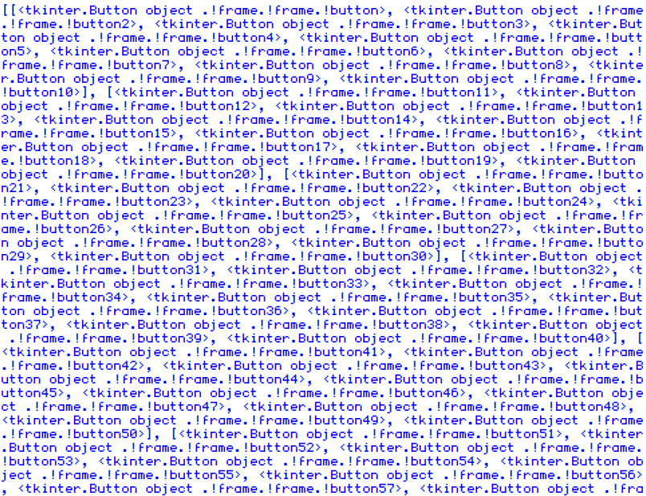
This is the output. The references to the buttons are intact, and we can reference them using buttonArray[x][y].

We could even take this one step further, instead of appending the button to the button array right after it is initialised, we will append the button to the array only if the button is interactive to the user. This is so we don’t include the horizontal and vertical hints as part of the button array. We can replace this section of code:
if x >= hintsHorizontalMinimum and y >= hintsVerticalMinimum: # Cells for user to interact with
pass # Do nothing, this section of code was useful for debugging purposes
with this:
if x >= hintsHorizontalMinimum and y >= hintsVerticalMinimum: # Cells for user to interact with
rowButtonArray.append(button)
Now, only the user interactable buttons are part of the buttonArray array.

We should be able to reference any button we want. We can do a test just to make sure we can reference any button we want.
def verify():
buttonArray[-2][-2].grid_forget()
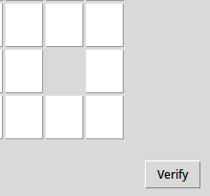
This should make the cell that is one space away from the bottom right corner disappear.
After performing another test, this is the case. The next thing to do is write a routine that will input the entire user solution into a blank nonogram array. We can use two arrays to do this: solutionArray and a temporary array named solutionRowArray.

def verify(): # After the user presses the 'Verify' button
solutionArray = [] # Blank master array for the users solution
for y in range(len(buttonArray[0])): # Iterate through columns...
solutionRow = "" # Define blank temporary row variable
for x in range(len(buttonArray)): # For horizontal length of buttons
if buttonArray[x][y].cget("bg") == "black": # If BG colour is black...
solutionRow = solutionRow + "1" # Append a 1 to row
else: # Otherwise...
solutionRow = solutionRow + "0" # Append a 0 to row
solutionArray.append(solutionRow) # After each row, append the row to the main array
if debug == True:
print("Original array:")
print(nonogram) # Original array
print("User solution:")
print(solutionArray) # For debugging/output purposes

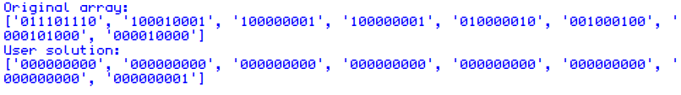
This will return the values of both of the arrays. However, we will need to write an extra subroutine to check if the two lists are equal.

Checking lists function
def checkLists(list1,list2): # Used in the verification process
if len(list1) != len(list2): # If there is a different vertical size...
print("Error! Vertical size different.")
return False # Return False
elif len(list1[0]) != len(list2[0]): # If there is a different horizontal size...
print("Error! Horizontal size different.")
return False # Return True
else:
match = True
for row in range(len(list1)):
for column in range(len(list1[0])):
if list1[row][column] != list2[row][column]:
match = False
if match == False:
return False
else:
return True
This function will take a parameter of two lists. It first does two quick checks, is the vertical and horizontal size of the first list different to the second list? If so, it prints an error message to the Python shell window, however this will never be seen by an end user as the two arrays should always be of the same length.
We then iterate through every row and column of the first list to test if it equals the same as the second list. If they do not match, the variable match is set to False. Otherwise, it remains true. At the end of the program, it checks if the match variable is set to False and returns False. Otherwise, return True and assume they are matching.
After the verify button is pressed, we will include a popup box whether the user has been successful in solving the nonogram puzzle. We will include their current time in this popup box as well. Redefine the verify function as:

import time
...
endTimes = []
def verify(): # After the user presses the 'Verify' button
solutionArray = [] # Blank master array for the users solution
for y in range(len(buttonArray[0])): # Iterate through columns...
solutionRow = "" # Define blank temporary row variable
for x in range(len(buttonArray)): # For horizontal length of buttons
if buttonArray[x][y].cget("bg") == "black": # If BG colour is black...
solutionRow = solutionRow + "1" # Append a 1 to row
else: # Otherwise...
solutionRow = solutionRow + "0" # Append a 0 to row
solutionArray.append(solutionRow) # After every row, append the row to the master array
if debug == True:
print("Original array:")
print(nonogram) # Original array
print("User solution:")
print(solutionArray) # For debugging/output purposes
print(checkLists(nonogram,solutionArray))
if checkLists(nonogram,solutionArray) == True:
endTimes.append(time.time())
messagebox.showinfo(title="Success", message="Nonogram puzzle matches!\nCongratulations on solving the nonogram puzzle. Your time was " + str(endTimes[0] - startTime)[:4] + " seconds.")
else:
messagebox.showwarning(title="Failed", message="The inputted nonogram does not match the final solution.")

Now, we should have code that gives us a popup box when the nonogram has been completed correctly with the first/initial time taken to verify. If the user is not successful in completing the nonogram, the popup box will notify them that the nonogram puzzle does not match.

Puzzle solving test
We will perform a test to make sure this is working correctly. We will take some nonogram puzzles of varying sizes. For the first test per puzzle, we will intentionally input an incorrect solution. For the second test per puzzle, we will intentionally input the correct puzzle. We are testing to see whether the output of print(checkLists(nonogram,solutionArray)) is equal to True.

Puzzle name  Puzzle size (horizontal x vertical) |  | Does the program return the correct state of whether the original and completed nonogram are identical?
 |  | First test  Puzzle is solved incorrectly on purpose to check that it will print a ‘Failed’ dialog | Second test  Puzzle is solved correctly to check that it will print a ‘Success’ dialog with time elapsed since initialisation
heart.txt | 9x8 | Test success ✅  Returns False  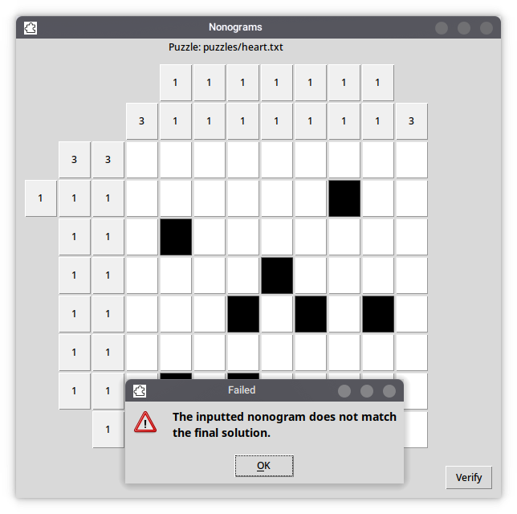 | Test success ✅  Returns True  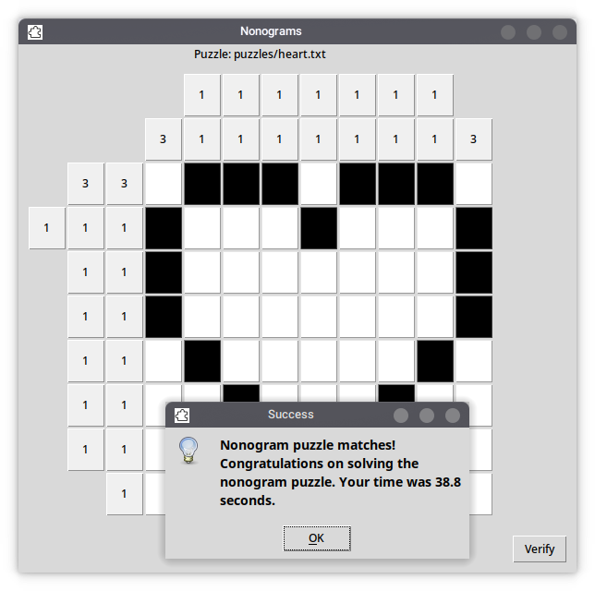
box.txt | 4x4 | Test success ✅  Returns False  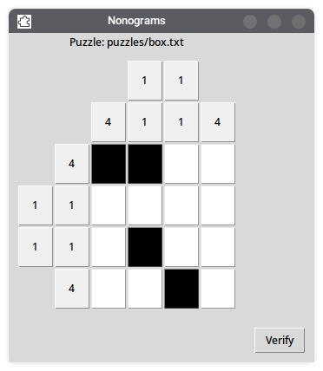 | Test success ✅  Returns True  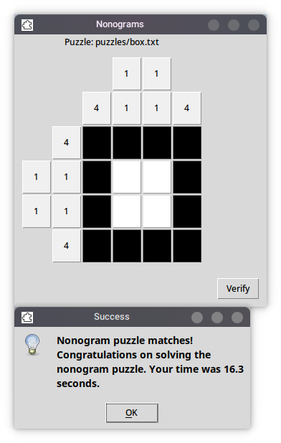
smiley.txt | 7x7 | Test success ✅  Returns False  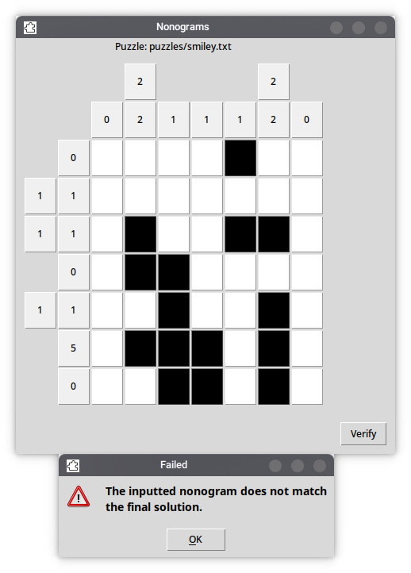 | YTest successes ✅  Returns True  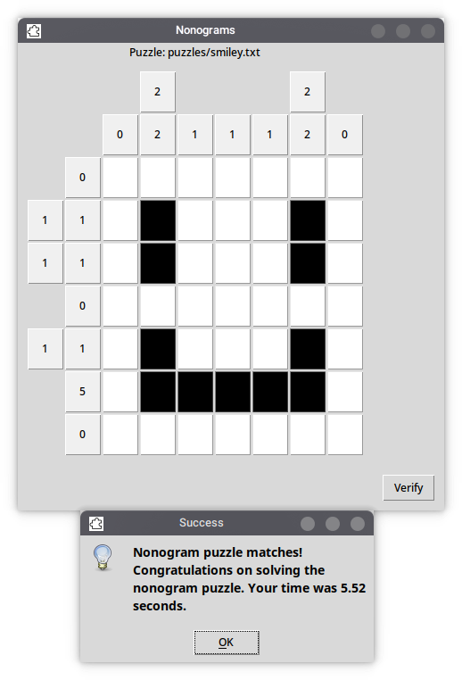
pixels.txt | 9x9 | Test success ✅  Returns False  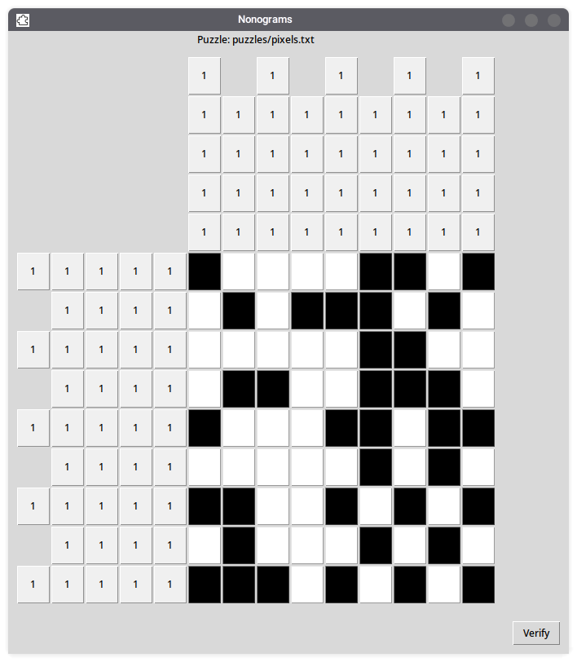 | Test success ✅  Returns True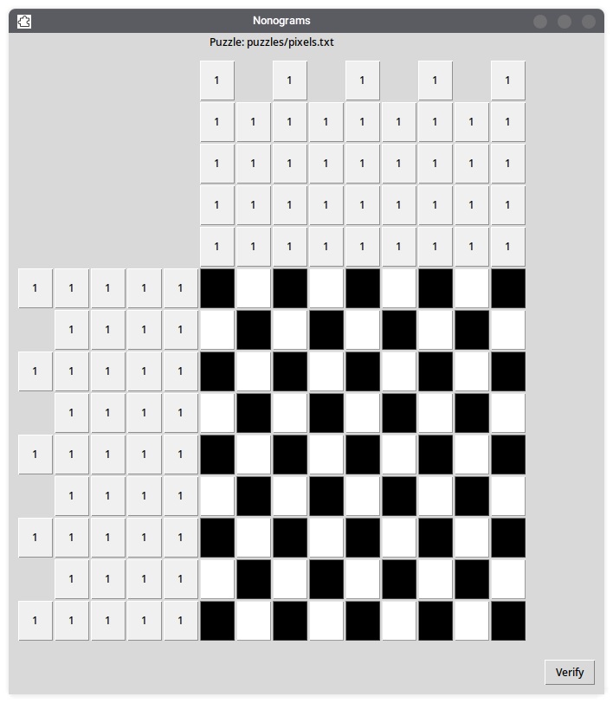
generic.txt | 10x10 | Test success ✅  Returns False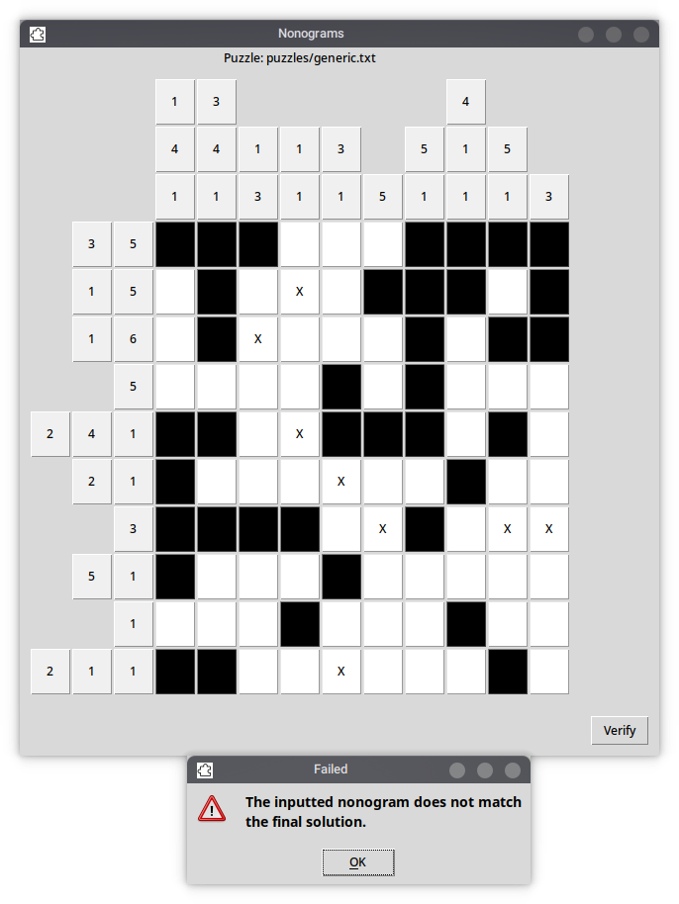 | Test success ✅  Returns True  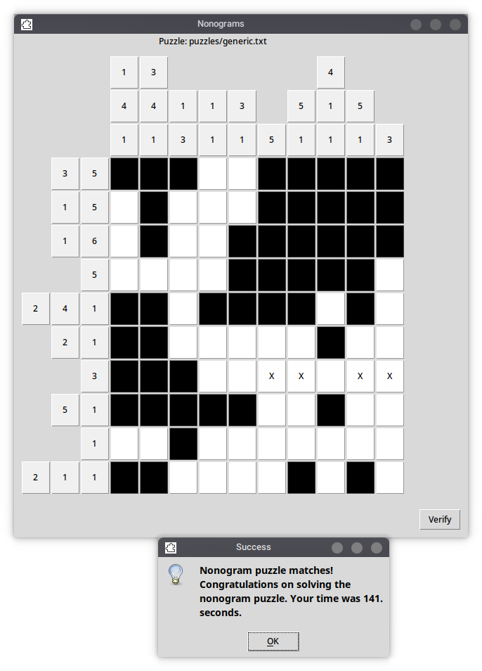

Main menu/launcher
Up until this point, we have been manually specifying the filename of the nonogram we are importing at the start of the main program which is a hardcoded method. It would be more useful for the user if we could implement a menu, such as discussed in ‘Selection GUI’ of the Design section. We can very easily solve this by creating a new Python file named nonogramdialog.py which is imported as a module at the start of main.py.
import tkinter as tk # Base toolkit
import os # For listing directory functionality
from tkinter import simpledialog # Simple ask dialog inputting a string
from tkinter import messagebox # To display error in case of non-existent file
from os.path import exists
valid = False
root = tk.Tk()
root.withdraw()
while valid == False:
# Below line is inputting dialog from user and storing it in a variable
filename = simpledialog.askstring(title="Nonogram Selector", prompt=
"Nonograms by Candidate 0367 for OCR A Level Computer Science 2022\nProgram written in Python using the Tkinter toolkit.\n=========================================================\nPlease input the relative path to a nonogram file in the puzzles directory.\nAvaliable puzzles: "
+ str(os.listdir("puzzles")).translate({ord(c): None for c in '[]'}))
if filename[:8] != "puzzles/": # If the string doesn't start with 'puzzles/',
filename = "puzzles/" + filename # Pretend as if it does
if filename[-4:] != ".txt": # If file does not end in .txt...
filename = filename + ".txt" # Pretend as if it does
if exists(filename) == False: # If file exists on drive...
messagebox.showerror(title="Error",message="File must exist.") # Message box to user
else:
valid = True # Break clause to escape loop/program
This provides a nice dialog box for the user to type in the name of their preferred nonogram. Additionally, we have printed a copy of the nonogram puzzles directory using a function of the os library and appended it to the dialog box label.
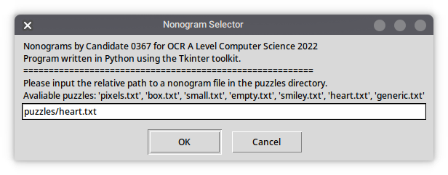
This is what the current input dialog looks like. It has been made as user-friendly as possible, as it will accept:
- Puzzle name without directory or .txt extension
  - e.g: heart
- Puzzle name with directory (puzzles/) but excluding .txt extension
  - e.g: puzzles/heart
- Puzzle name without directory but including .txt extension
  - e.g: heart.txt
- Puzzle name including both directory and .txt extension
  - e.g: puzzles/heart.txt

Nonogram creation
The user can already manually create nonograms by placing 1s and 0s in a text document in the puzzles folder, however this is not very intuitive and requires manual knowledge of how the program works. We will have special nonogram functionality in the program to make our own. First, we will accept the string ‘create’ in the nonogram selection dialog in the previous subsection.
if filename == "create":
valid = True
We can adapt much of the previous code in the main.py section for this new nonogram creation mode. There are certain things we can change or remove, however.
- Backend (e.g: importing nonogram as data structure, generating horizontal and vertical hints and minimum squares based on those hints)
  - We can safely remove this code, there is nothing being imported here.
  - We will however have to introduce a new dialog to specify the horizontal and vertical size of the nonogram. We can do so with the following code at the start of the nonogram creation subroutine:
horizontalSize = int(simpledialog.askstring(title="Nonogram Horizontal Size", prompt="How many tiles wide do you want your nonogram to be? Enter number."))
verticalSize = int(simpledialog.askstring(title="Nonogram Vertical Size", prompt="How many tiles tall do you want your nonogram to be? Enter number."))
- Nonogram ‘marking’ right-click function
  - We do not need this code, we can completely strip it. We still need the ‘filled-in’ code for left-click functionality so I will only remove this part.

Final coded solution
# nonogramdialog.py
import tkinter as tk # Base toolkit
import os # For listing directory functionality
from tkinter import simpledialog # Simple ask dialog inputting a string
from tkinter import messagebox # To display error in case of non-existent file
from os.path import exists # To check if file exists
valid = False
root = tk.Tk()
root.withdraw()
while valid == False:
# Below line is inputting dialog from user and storing it in a variable
filename = simpledialog.askstring(title="Nonogram Selector", prompt="Nonograms by Candidate 0367 for OCR A Level Computer Science 2022\nProgram written in Python using the Tkinter toolkit.\n=========================================================\nPlease input the relative path to a nonogram file in the puzzles directory.\nAvaliable puzzles: " + str(os.listdir("puzzles")).translate({ord(c): None for c in '[]'}) + "\nAlternatively, type 'create' to create a new nonogram puzzle.")
filename = filename.lower()
if filename == "create":
valid = True
else:
if filename[:8] != "puzzles/": # If the string doesn't start with 'puzzles/',
filename = "puzzles/" + filename # Pretend as if it does
if filename[-4:] != ".txt": # If file does not end in .txt...
filename = filename + ".txt" # Pretend as if it does
if exists(filename) == False: # If file exists on drive...
messagebox.showerror(title="Error",message="File must exist.") # Message box to user
else:
valid = True # Break clause to escape loop/program

# main.py
from tkinter import * # CORE to the program, GUI toolkit
from tkinter import simpledialog # Simple ask dialog inputting a string
from tkinter import messagebox # For displaying message boxes and erorrs
import time # For printing time taken to solve the puzzle
from os.path import exists # To check if file exists
import nonogramdialog
print("=================================================================")
print("Nonograms by Candidate 0367 for OCR A Level Computer Science 2022")
print("Program written in Python using the Tkinter toolkit.")
print("=================================================================")
filename = nonogramdialog.filename # Relative .txt file to be loaded
debug = True # NOT VISIBLE TO END USER, for development output only!
if filename != "create":
# DATA STRUCTURE SECTION 1:
# Basic input of the nonogram text file into an array
with open(filename) as file_in:
nonogram = [] # Initialises blank nonogram
for line in file_in: # Iterates through each line in the file...
nonogram.append(line.rstrip('\n')) # Calls rstrip function to remove linebreaks and /n
if debug == True:
print("Nonogram data file = " + filename + "\n") # Debug: prints relative data file
print("Nonogram data structure = " + str(nonogram) + "\n") # Debug: prints the actual data structure array
# Basic validation to make sure the nonogram has a minimum size of 2x2
if (len(nonogram) < 2 or len(nonogram[0]) < 2):
messagebox.showerror("Puzzle size error","Nonogram must have a minimum size of 2x2.\nThe loaded nonogram '" + filename + "' has a size of " + str(len(nonogram[0])) + "x" + str(len(nonogram)) + ".")
quit()
# STRUCTURE SECTION 2:
# Algorithm below is to generate the horizontal key/hints for the current puzzle
hintsHorizontal = []
for row in nonogram: # Iterate through each row
consecutiveCount = 0 # For every row, reset consecutiveCount to 0
rowHints = []
for value in row: # Iterate through each value within row
if value == "1":
consecutiveCount += 1 # Count is incremented per filled-in box
elif value == "0":
if int(consecutiveCount) > 0: # Test to see if > 0
rowHints.append(consecutiveCount) # Count is appended...
consecutiveCount = 0 # ...and then reset.
if consecutiveCount > 0: # JUST IN CASE the last value of a row is a 1
rowHints.append(consecutiveCount) # Gives it a chance to be appended
hintsHorizontal.append(rowHints)
if debug == True:
print("hintsHorizontal = " + str(hintsHorizontal)) # For debugging/output purposes
# Code to generate the minimum number of squares to represent the row hints
# This will be very important later for the GUI grid size
hintsHorizontalMinimum = 0
for row in hintsHorizontal:
count = 0
for hint in row:
count += 1
if count > hintsHorizontalMinimum:
hintsHorizontalMinimum = count
if debug == True:
print("hintsHorizontalMinimum = " + str(hintsHorizontalMinimum) + "\n") # For debugging/output purposes
# STRUCTURE SECTION 3:
# Algorithm below is to generate the vertical key/hints for the current puzzle
hintsVertical = []
for column in range(len(nonogram[0])): # Iterating column
consecutiveCount = 0 # For every column, reset consecutiveCount to 0
columnHints = []
for value in range(len(nonogram)): # Iterating number in column
if nonogram[value][column] == "1":
consecutiveCount += 1 # Consecutive count is incremented by one
elif nonogram[value][column] == "0":
if int(consecutiveCount) > 0: # Test to see if > 0
columnHints.append(consecutiveCount) # Count is appended...
consecutiveCount = 0 # ...and then reset.
if consecutiveCount > 0: # JUST IN CASE the last value of a column is a 1
columnHints.append(consecutiveCount) # Gives it a chance to be appended
hintsVertical.append(columnHints)
if debug == True:
print("hintsVertical = " + str(hintsVertical)) # For debugging/output purposes
# Code to generate the minimum number of squares to represent the column hints
# This will be very important later for the GUI grid size
hintsVerticalMinimum = 0
for column in hintsVertical:
count = 0
for hint in column:
count += 1
if count > hintsVerticalMinimum:
hintsVerticalMinimum = count
if debug == True:
print("hintsVerticalMinimum = " + str(hintsVerticalMinimum) + "\n") # For debugging/output purposes
if debug == True:
print("=================================================================")
print("DEBUG END")
print("=================================================================")
# STRUCTURE SECTION 4:
# Graphical user interface in Tkinter for nonogram solving mode
root = Tk() # Initialise Tk root
frame = Frame(root) # Base frame
frame.grid(row=0, column=0, sticky="news")
root.title('Nonograms') # Sets window title to 'Nonograms'
root.iconbitmap("@icon.xbm") # Sets basic window icon
grid = Frame(frame) # Grid frame
grid.grid(sticky="news", column=0, row=2, columnspan=1, padx=(10,10),pady=(10,10))
puzzleText = Label(frame, text="Puzzle: " + filename)
puzzleText.grid(row=0,column=0)
#puzzleText2 = Label(frame, text=filename, font=('TkDefaultFont', 10, 'bold'))
#puzzleText2.grid(row=0,column=1,columnspan=2)
#elapsedTime = Label(frame, text="Time: ")
#elapsedTime.grid(row=3)
def toggle(event): # LEFT CLICK - Event to toggle BG color when button is pressed
button = event.widget # Passing through button to subroutine
if button.cget("bg") == "white": # If button is white...
button.configure(text="") # ...empty text in case of mark
button.configure(bg="black",activebackground="#0d0d0d") # ...set colour to black
elif button.cget("bg") == "black": # If button is black...
button.configure(bg="white",activebackground="#f0f0f0") # ... set colour to white
else:
pass
def mark(event): # RIGHT CLICK - Event to mark the cell with an X
button = event.widget # Passing through button to subroutine
if button.cget("bg") == "black":
button.configure(bg="white",activebackground="#f0f0f0")
button.configure(text="X")
elif button.cget("bg") == "white":
if button.cget("text") == "X":
button.configure(text="")
else:
button.configure(text="X")
def checkLists(list1,list2): # Used in the verification process
if len(list1) != len(list2): # If different vertical size...
print("Error! Vertical size different.")
return False # Return False
elif len(list1[0]) != len(list2[0]): # If different horizontal size...
print("Error! Horizontal size different.")
return False # Return True
else:
match = True
for row in range(len(list1)):
for column in range(len(list1[0])):
if list1[row][column] != list2[row][column]:
match = False
if match == False:
return False
else:
return True
endTimes = []
def verify(): # After the user presses the 'Verify' button
solutionArray = [] # Blank master array for the users solution
for y in range(len(buttonArray[0])): # Iterate through columns...
solutionRow = "" # Define blank temporary row variable
for x in range(len(buttonArray)): # For horizontal length of buttons
if buttonArray[x][y].cget("bg") == "black": # If BG colour is black...
solutionRow = solutionRow + "1" # Append a 1 to row
else: # Otherwise...
solutionRow = solutionRow + "0" # Append a 0 to row
solutionArray.append(solutionRow) # After every row, append the row to the master array
if debug == True:
print("Original array:")
print(nonogram) # Original array
print("User solution:")
print(solutionArray) # For debugging/output purposes
print(checkLists(nonogram,solutionArray))
if checkLists(nonogram,solutionArray) == True:
endTimes.append(time.time())
messagebox.showinfo(title="Success", message="Nonogram puzzle matches!\nCongratulations on solving the nonogram puzzle.\nYour time was " + str(endTimes[0] - startTime)[:4] + " seconds.")
else:
messagebox.showwarning(title="Failed", message="The inputted nonogram does not match the final solution.")
verifyButton = Button(frame,text="Verify",command=verify)
verifyButton.grid(row=4,column=1,padx=(10,10),pady=(10,10))
# This below section of code has the following purposes:
# We are iterating through horizontally the length of the nonogram puzzle + the hints.
# We are iterating through vertically the height of the nonogram puzzle + the hints.
# We are defining a button for every single cell of the nonogram puzzle and every hint.
#
startTime = time.time()
buttonArray = []
for x in range(len(nonogram[0]) + hintsHorizontalMinimum): # Iterate per row...
rowButtonArray = []
for y in range(len(nonogram) + hintsVerticalMinimum): # Iterate per column...
button = Button(grid, width="2",height="2", bg="white") # Initialise a new button...
button.grid(column=x, row=y) # ...as part of grid
if x < hintsHorizontalMinimum and y < hintsVerticalMinimum: # If the button is in the top left corner (redundant)...
button.grid_forget() # Forget the buttons on the grid
if x >= hintsHorizontalMinimum and y >= hintsVerticalMinimum: # Cells for user to interact with
rowButtonArray.append(button)
pass # Do nothing, this section of code was useful for debugging purposes
else:
button.configure(bg="#f0f0f0") # Set to default BG colour
if x < hintsHorizontalMinimum: # Selecting JUST the horizontal hints...
if (hintsHorizontalMinimum-x-1 < len(hintsHorizontal[y-hintsVerticalMinimum])): # Only applying if in range
#button.configure(text=hintsHorizontal[y-hintsVerticalMinimum][hintsHorizontalMinimum-x-1]) # Setting the text to the correct hint
button.configure(text=hintsHorizontal[y-hintsVerticalMinimum][x-hintsHorizontalMinimum]) # Setting the text to the correct hint
else: # If there is no text to set,
if (hintsHorizontalMinimum-x-1 > 0): # If it is not the only button on that row,
button.grid_forget() # remove the horizontal button.
else:
button.configure(text="0") # Set to 0 otherwise
if y < hintsVerticalMinimum: # Selecting JUST the vertical hints...
if (hintsVerticalMinimum-y-1 < len(hintsVertical[x-hintsHorizontalMinimum])): # Only applying if in range
button.configure(text=hintsVertical[x-hintsHorizontalMinimum][y-hintsVerticalMinimum]) # Setting the text to the correct hint
else: # If there is no text to set,
if (hintsVerticalMinimum-y-1 > 0): # If it is not the only button on that column,
button.grid_forget() # remove the vertical button.
else:
button.configure(text="0") # Set to 0 otherwise
button.bind("<Button-1>", toggle) # When the left mouse button is pressed, call the toggle function
button.bind("<Button-3>", mark) # When the right mouse button is pressed, call the mark function
if x >= hintsHorizontalMinimum:
buttonArray.append(rowButtonArray)
root.mainloop()
elif filename == "create":
# STRUCTURE SECTION 5:
# Graphical user interface in Tkinter for nonogram creation mode
horizontalSize = int(simpledialog.askstring(title="Nonogram Horizontal Size", prompt="How many tiles wide do you want your nonogram to be? Enter number."))
verticalSize = int(simpledialog.askstring(title="Nonogram Vertical Size", prompt="How many tiles tall do you want your nonogram to be? Enter number."))
root = Tk() # Initialise Tk root
frame = Frame(root) # Base frame
frame.grid(row=0, column=0, sticky="news")
root.title('Nonogram Creator') # Sets window title to 'Nonograms'
root.iconbitmap("@icon.xbm") # Sets basic window icon
grid = Frame(frame) # Grid frame
grid.grid(sticky="news", column=0, row=2, columnspan=1, padx=(10,10),pady=(10,10))
def toggle(event): # LEFT CLICK - Event to toggle BG color when button is pressed
button = event.widget # Passing through button to subroutine
if button.cget("bg") == "white": # If button is white...
button.configure(text="") # ...empty text in case of mark
button.configure(bg="black",activebackground="#0d0d0d") # ...set colour to black
elif button.cget("bg") == "black": # If button is black...
button.configure(bg="white",activebackground="#f0f0f0") # ... set colour to white
else:
pass
def save():
nonogram = [] # Blank master array for the users solution
for y in range(verticalSize): # Iterate through columns...
row = "" # Define blank temporary row variable
for x in range(horizontalSize): # For horizontal length of buttons
if buttonArray[x][y].cget("bg") == "black": # If BG colour is black...
row = row + "1" # Append a 1 to row
else: # Otherwise...
row = row + "0" # Append a 0 to row
nonogram.append(row) # After every row, append the row to the master array
if debug == True:
print("Created nonogram:")
print(nonogram) # Created nonogram
exists = True
nonogramName = simpledialog.askstring(title="Nonogram Name", prompt="What would you like to name the nonogram?")
if nonogramName[:8] != "puzzles/": # If the string doesn't start with 'puzzles/',
nonogramName = "puzzles/" + nonogramName # Pretend as if it does
if nonogramName[-4:] != ".txt": # If file does not end in .txt...
nonogramName = nonogramName + ".txt" # Pretend as if it does
#if exists(nonogramName) == True: # If file exists on drive...
# messagebox.showerror(title="Error",message="File must not exist.") # Message box to user
if debug == True:
print(nonogramName)
textfile = open(nonogramName, "w")
for element in nonogram:
textfile.write(element + "\n")
textfile.close()
messagebox.showerror(title="Success",message="Nonogram has been written to " + nonogramName + ".") # Displaying success info
saveButton = Button(frame,text="Save",command=save)
saveButton.grid(row=4,column=1,padx=(10,10),pady=(10,10))
# This below section of code has the following purposes:
# We are iterating through horizontally the length of the nonogram puzzle + the hints.
# We are iterating through vertically the height of the nonogram puzzle + the hints.
# We are defining a button for every single cell of the nonogram puzzle and every hint.
#
buttonArray = []
for x in range(horizontalSize): # Iterate per row...
rowButtonArray = []
for y in range(verticalSize): # Iterate per column...
button = Button(grid, width="2",height="2", bg="white") # Initialise a new button...
button.grid(column=x, row=y) # ...as part of grid
button.configure(bg="white") # Set to default BG colour
button.bind("<Button-1>", toggle) # When the left mouse button is pressed, call the toggle function
rowButtonArray.append(button)
buttonArray.append(rowButtonArray)
root.mainloop()
else:
print("Error")

Evaluation

Testing to inform evaluation
Now that the program is complete, we are going to perform a series of rigorous testing to ensure that the core functionality of the program is complete. We will be testing the following aspects of the program:
- Nonogram playing mode
  - Does the nonogram load correctly to the display? Are there any errors displayed to the screen or shell, especially in edge cases? Are all of the buttons and hints visible without any noticeable deformities to the user interface?
  - Are all of the unnecessary cells removed? These would include:
    - Series of buttons at the top left that neither occupy the horizontal hints, vertical hints and main playing area of the program.
    - The horizontal and vertical hint buttons for which there is no hint for that specific cell.
  - Is the puzzle able to be completed and verified? When the nonogram is completed correctly, is the program able to recognise this and print a success message with the elapsed time to beat?

Nonogram playing mode

Puzzle name | Puzzle size (horizontal x vertical) | Nonogram loads to display | Unnecessary cells are removed | Horizontal and vertical hints display correctly | Puzzle is able to be completed and verified?
heart.txt | 9x8 | Yes ✅ | Yes ✅ | Yes ✅ | Yes ✅  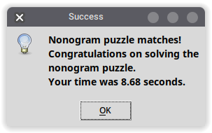
box.txt | 4x4 | Yes ✅ | Yes ✅ | Yes ✅ | Yes ✅  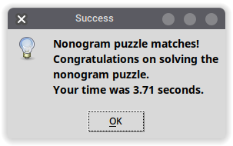
smiley.txt | 7x7 | Yes ✅ | Yes ✅ | Yes ✅ | Yes ✅  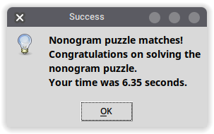
pixels.txt | 9x9 | Yes ✅ | Yes ✅ | Yes ✅ | Yes ✅  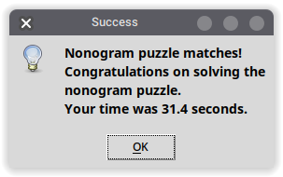
generic.txt | 10x10 | Yes ✅  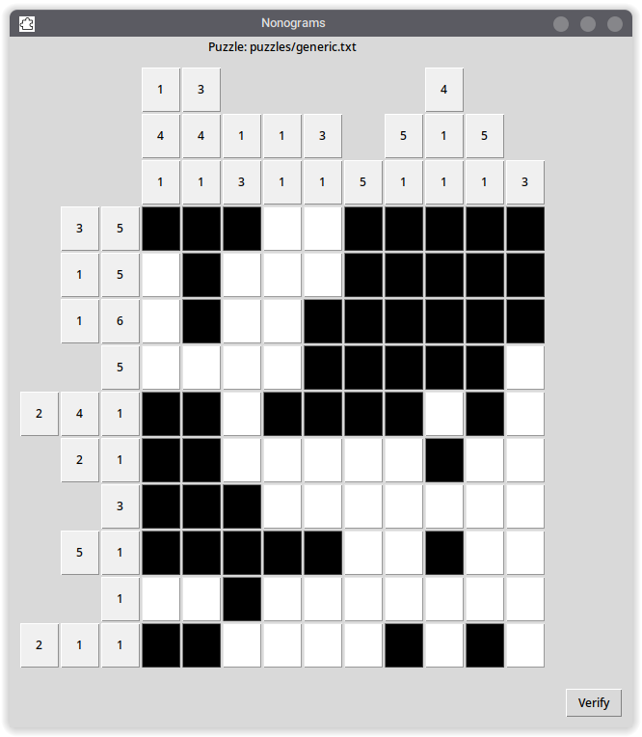 | Yes ✅ | Yes ✅ | Yes ✅  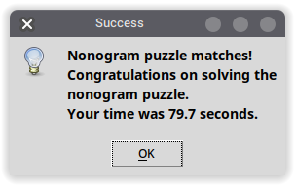

Nonogram creation mode

Puzzle name | Special attributes and edge cases | Nonogram creation grid loads | Program converts to array correctly? | Program file name goes through correctly? | Completed nonogram is saved to the folder as .txt? | Intended behaviour in ‘play’ mode?
filledin.txt | 5x5  Nonogram will be COMPLETELY filled in. We need to ensure the program can handle completely filled-in nonograms. | Yes ✅  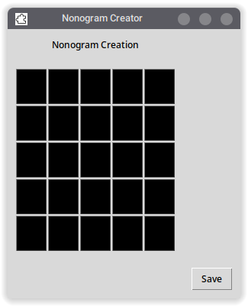  This nonogram creation grid loads correctly with the right specifications and can be filled in. | Yes ✅  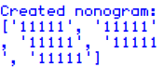 | Yes ✅ | Yes ✅  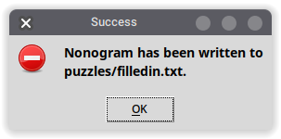   | Yes ✅  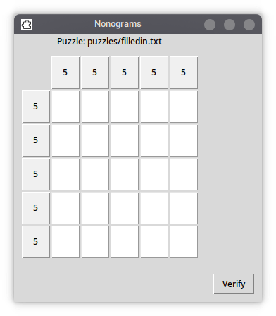
nothing.txt | 0x0  Nonogram will be completely empty. | Yes ✅  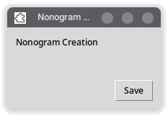  This nonogram creation grid loads the correct amount of buttons, none at all. This is intended behaviour. | Yes ✅  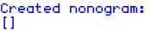  As the nonogram is empty, the array representing the data structure is blank. | Yes ✅ | Yes ✅  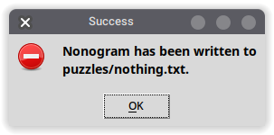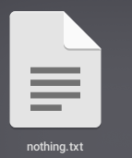 | Yes ✅  Minimum size error, this is the INTENDED BEHAVIOUR!  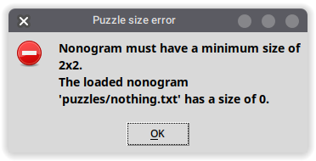

Evidence of solution

Test criteria
This was the test criteria provided at the beginning in the Analysis section. The original success criteria is below in green. I will provide blue annotated comments based on if the criteria of my project have been met.
- Working navigation UI and main menu with basic mouse and keyboard support 🖱️ ⌨️ ✅
  - This will be required by the stakeholder to navigate and use the program.
  - This is the bare minimum expectation of the program, the user should be able to interact with all of the elements and access all of the core functionality as specified below.
  - The user interface will be drawn using the Tkinter toolkit, each of the nonogram cells will be represented by buttons on the screen.
  - FULLY MET: The nonogram program is fully accessible to the user and has full mouse and keyboard support. The graphical user interface is responsive to user input and there are text fields where the user can enter the name of the nonogram when loading and saving.
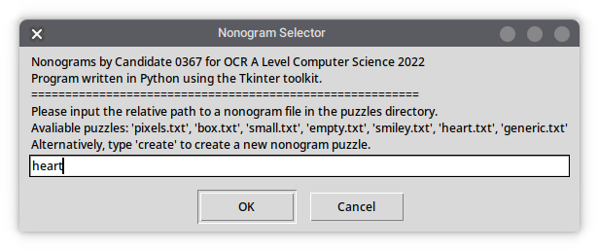
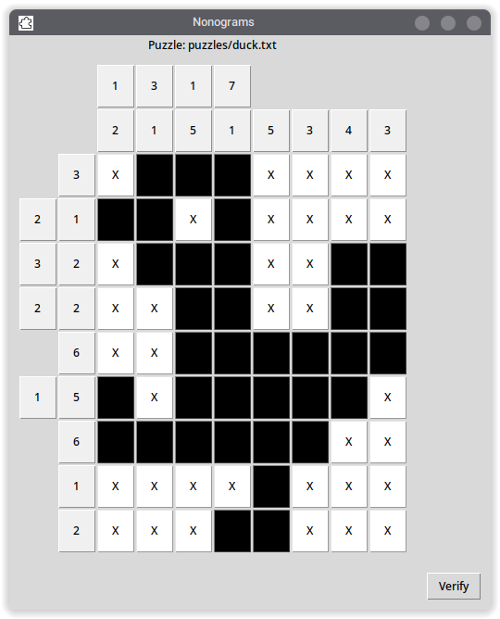
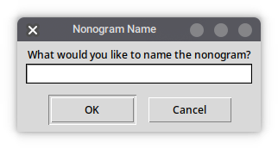
- Nonogram interface functional with ability to ‘fill in’ (left click) and ‘flag/mark’ (right click) ✅
  - This functionality of the program should only require two mouse buttons (left and right click), so that it is as easy as possible.
  - The left click and right click functions are both very important parts of the nonogram solution.
    - Left click to fill-in is how the user interacts with the nonogram solution when they are solving it; their solution will be compared against the original nonogram to ensure they have solved the puzzle correctly. Thus, it is important this is a functioning part of the program.
    - Right click to mark is a cosmetic feature that allows the user to embark a ‘divide and conquer’ approach for completing the puzzle. They will be able to mark cells they know are safe similar to the mines in the game Minesweeper, improving the quality of life and user experience.
  - FULLY MET: The left and right clicking functionality is working completely as intended. Upon a left or right press of the mouse button, the button calls the toggle() or mark() subroutines I have created and calls on the button method appropriately.
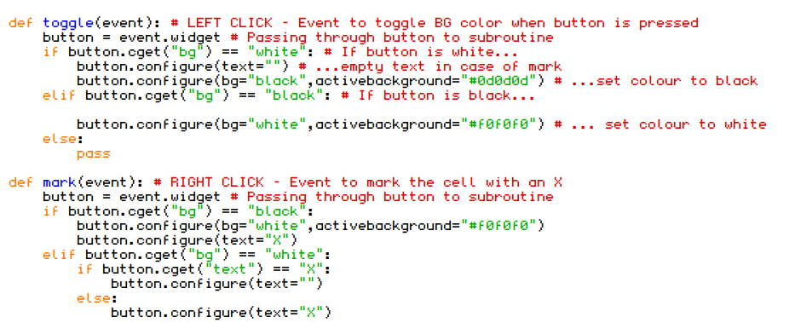
  - See the test data included in the ‘Nonogram playing mode’ section above for further evidence.
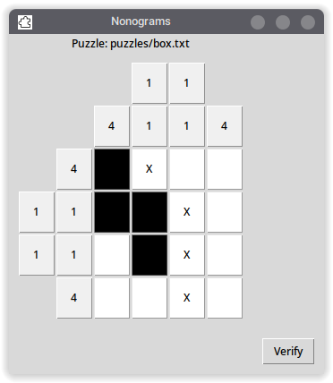
- Ability to share nonograms directly to people 📦 ✅
  - Having this is an important feature for people wanting to share and distribute puzzles between friends or even students in a class environment.
  - This could either be done by storing the nonograms as files on the local disks where they can be shared between computers, or even a potential networked solution with an online database of nonogram puzzles that users can upload using the built-in nonogram creation tool.
  - FULLY MET: The nonogram creation tool allows users to make nonograms and share them with their friends and colleagues. The .txt files are accessible in the ‘puzzles’ subfolder in the main project directory, so these can be copied and shared to other people’s computers.
  - In further development, I could create a transfer system or database that the nonograms are uploaded to, instead of being saved locally, allowing users to share puzzles without exiting the app.
- Nonogram verifying functionality 📑 ✅
  - Being able to verify the user’s solution to the nonogram puzzle is a very important part of the program.
  - After the user thinks they have solved the puzzle, they will press the ‘verify button’ and a copy of their completed nonogram will be stored as an array. This array would then be verified against the original nonogram array from when the puzzle is imported, and if they match, the user is displayed a success message with the elapsed time taken to complete. If the arrays do not match, the user is told they haven’t yet completed the nonogram puzzle.
  - FULLY MET: The user can press the ‘Verify’ button to call upon the verify() subprocedure I have created to make sure that they have inputted the correct solution, and displays this to the user including the elapsed time since initialisation of the nonogram puzzle.
  - With further development, a ‘brute force’ technique could be implemented which would input nonogram hints (e.g: hintsHorizontal and hintsVertical) and would custom brute force a nonogram solution through mathematical algorithms.
- Ability to create nonogram puzzles ✅
  - This could be through the nonogram user interface itself, or through interfacing with a text document.
  - FULLY MET: The user can choose at the main menu to create a nonogram, with the ability to specify a custom horizontal and vertical size. They can fill in any of the squares black or white, and there is a ‘save’ button on the nonogram screen. Once pressing this, the user is asked to input a custom nonogram file name, and their custom nonogram will be saved to a text file in the puzzles subfolder of the nonograms directory.
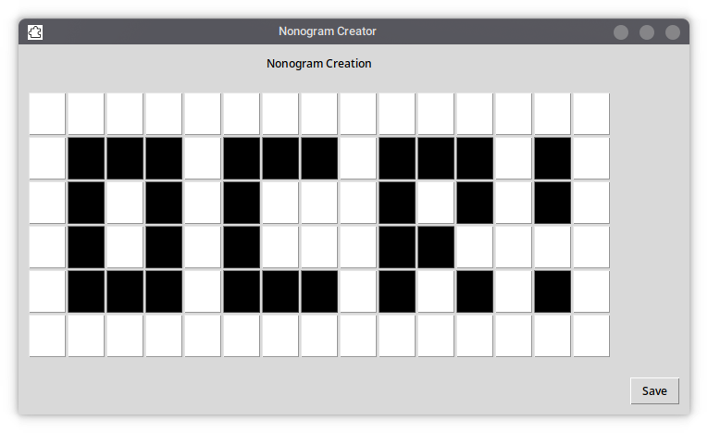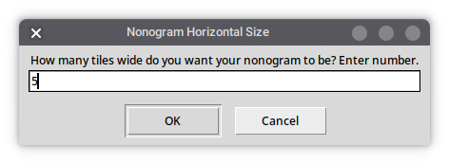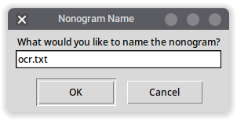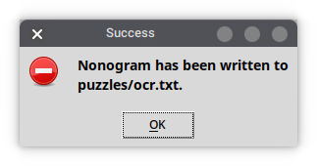
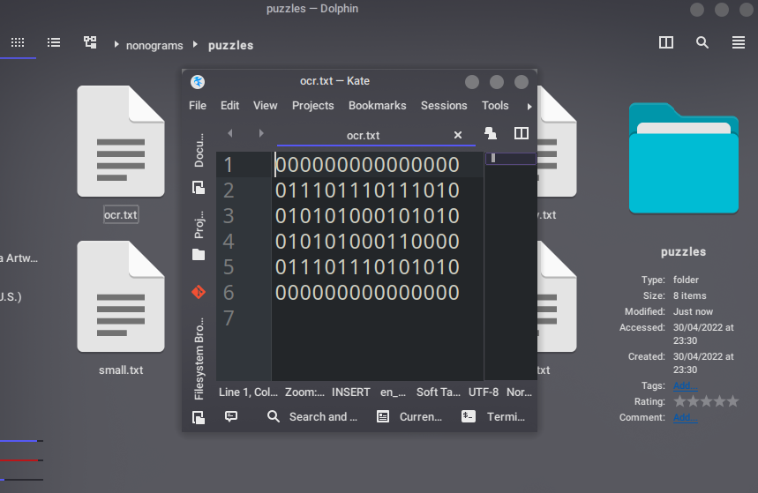

Extension/challenge criteria:
- Ability to play puzzles of rectangular sizes with UI scaled appropriately ✅
  - This could be done in two ways:
    - Fixed-size nonograms: There are certain nonogram presets such as 5x5, 10x10 or 15x15, etc. Nonograms must be made in this format otherwise the nonogram will fail to load.
    - Dynamically-sized nonograms: The nonogram grid will be initialised dynamically for a custom size. The horizontal and vertical sizes could even be different to one another, allowing for a 20x5 nonogram or a 12x7 nonogram for example.
  - FULLY MET: When I began development on the nonogram project, I made sure to be as modular and dynamic as possible when it came to constructing the data structures and graphical user interface. This means it is possible to create and play a nonogram of any size, even uneven and rectangular nonograms.
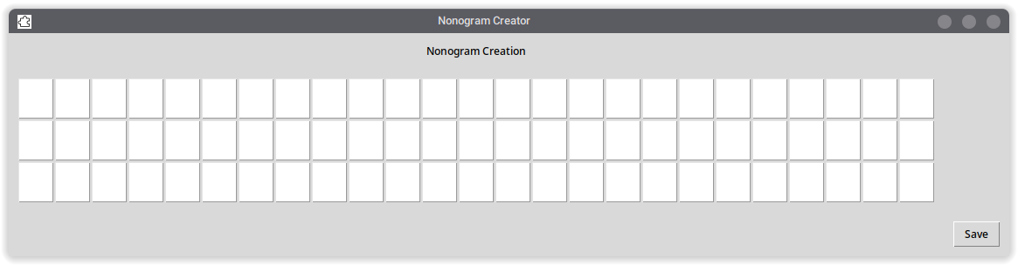
- Ability to search and share nonograms via an online database 🚫
  - In the far future, the nonogram program could be adapted to connect to an online database using an Internet connection to share, download and upload nonogram puzzles and distribute them with one another. This would allow for an abundance of nonogram puzzles as the community would be constantly creating them and sharing them.
  - NOT MET: There would be a lot of potential to make an online database based on the nonogram project. In further development, the program could be implemented as such it would receive and parse a list from a remote database of nonograms and the user can select any of these that they want. They could even choose to upload their own nonograms that they have created to the database, and users could share their nonogram links/IDs with one another for easy sharing of the same puzzle.
  - A leaderboard could also easily be implemented; within the functionality of my code, the time elapsed is displayed once the nonogram puzzle is completed for the first time. This could be uploaded to the remote database with the nonogram to compare times with other users and friends!

Maintenance issues and limitations
The program in its current state is complete and does not require continual modification from this point. If the stakeholder finds any additional bugs, these can be reported and a fix could be issued in further development, however this is unlikely due to the during and post development that me and my stakeholder have conducted.
One potential maintenance issue is if the user creates too many nonograms, they will begin to fill up the disk and overload the label when the nonogram directory is queried in the program.
With further development, the option to delete nonograms could be included in the main menu of the application. Or, a separate cleaning tool could be developed for removing nonograms which have not been played in a certain period of time, or the user is unlikely to access anymore. Also, one slight issue is if the user accidentally overwrites the original nonograms that came in the puzzles directory, which could happen with enough use of the program or if the user is not careful. During the nonogram creation stage, a new conditional statement could be created to check that the filename is not equal to one of the presets, and to force a different file name if this is the case.

Plenary
I have sent the completed application to my main stakeholder Adam for one last opportunity for feedback. He commented:
“Wow, this program completely fulfils the initial specification that I was looking for. I’m impressed with the extended functionality to create nonograms directly within the program itself as it’s a lot easier for me to visualise than just typing into a text document. It would be cool in the future if the program could connect with other users to access their nonograms, but I will be having a lot of fun in the meantime completing some of these nonogram puzzles and making my own to share with some of my other friends.”
I would love to think about continuing to think of new ways to expand the nonogram project under further development. The feedback I have received from testers is highly positive and I can’t wait to share this with people and continue testing.

See ‘Requirements for the solution including hardware and software’ section below
See ‘Nonogram data representation’ under ‘Design choices’ in the ‘Design’ section
For the sake of development, we are using Python 3.10.4, however most versions of Python 3 should be compatible.
Constructing Simple Nonograms of Varying Difficulty, University of Antwerp, Belgium https://liacs.leidenuniv.nl/~kosterswa/constru.pdf
See ‘Making user interface more accessible’ in Implementation
See ‘Checking lists function’ in Implementation
As explained early in the Design choices section (e.g: 00110110)

